Temple Emanuel of Newton – Agnon Tour
June 2015

Introduction: Jerusalem in Agnon's life
"מתוך קטסטרופה היסטורית שהחריב טיטוס מלך רומי את ירושלים וגלה ישראל מארצו, נולדתי אני באחת מערי הגולה, אבל בכל עת תמיד דומה הייתי עלי כמי שנולד בירושלים."

As a result of the historic catastrophe in which Titus of Rome destroyed Jerusalem and Israel was exiled from its land, I was born in one of the cities of the Exile. But always I regarded myself as one who was born in Jerusalem. In a dream, in a vision of the night, I saw myself standing with my brother-Levites in the Holy Temple, singing with them the songs of David, King of Israel, melodies such as no ear has heard since the day our city was destroyed and its people went into exile. I suspect that the angels in charge of the Shrine of Music, fearful lest I sing in wakefulness what I had sung in dream, made me forget by day what I had sung at night; for if my brethren, the sons of my people, were to hear, they would be unable to bear their grief over the happiness they have lost. To console me for having prevented me from singing with my mouth, they enable me to compose songs in writing.
(Nobel Prize acceptance speech)
From Foe to Friends



"Until Talpiyot was built, the king of the winds ruled there throughout the land, and all his ministers and his servants - strong and grueling winds there on the mountain and in the valley, upon the hill and in the gorge, doing whatever their hearts desire, as if the land had been given to them alone. One time, I happened to get there. I saw that the place was nice and the air was pure, and the sky pure blue and the land spacious, and I strolled to my content…"
"I will not praise my home, as it is small, and I will not be ashamed of it for there are bigger and better than it. My home is small, but there is space in my home for a man like me who does not seek grandeur."

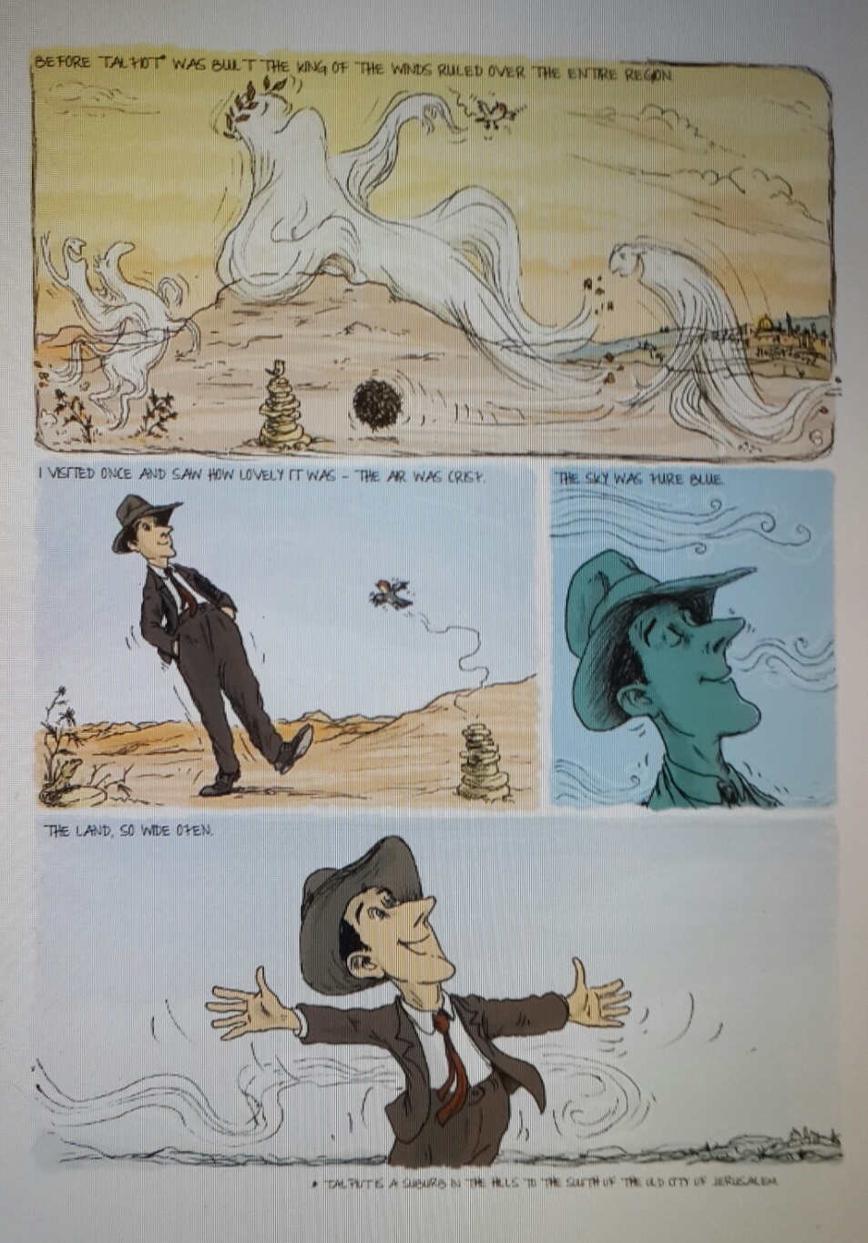
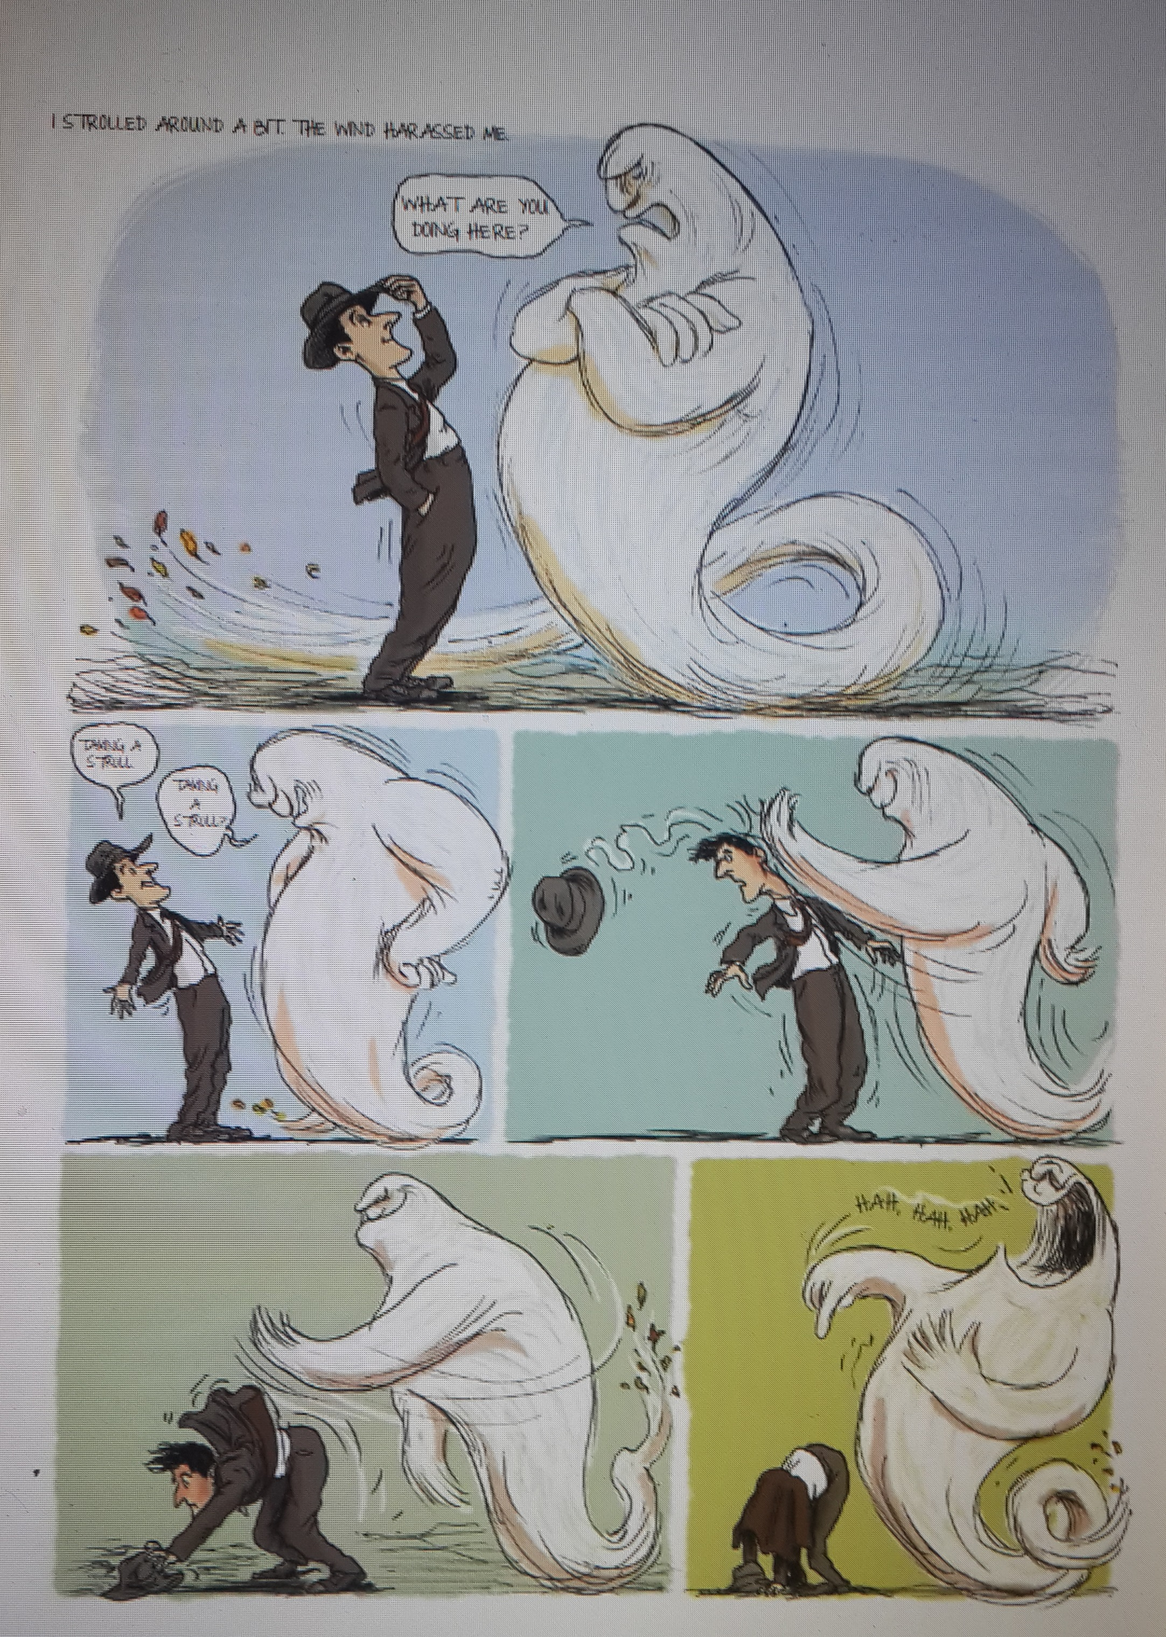
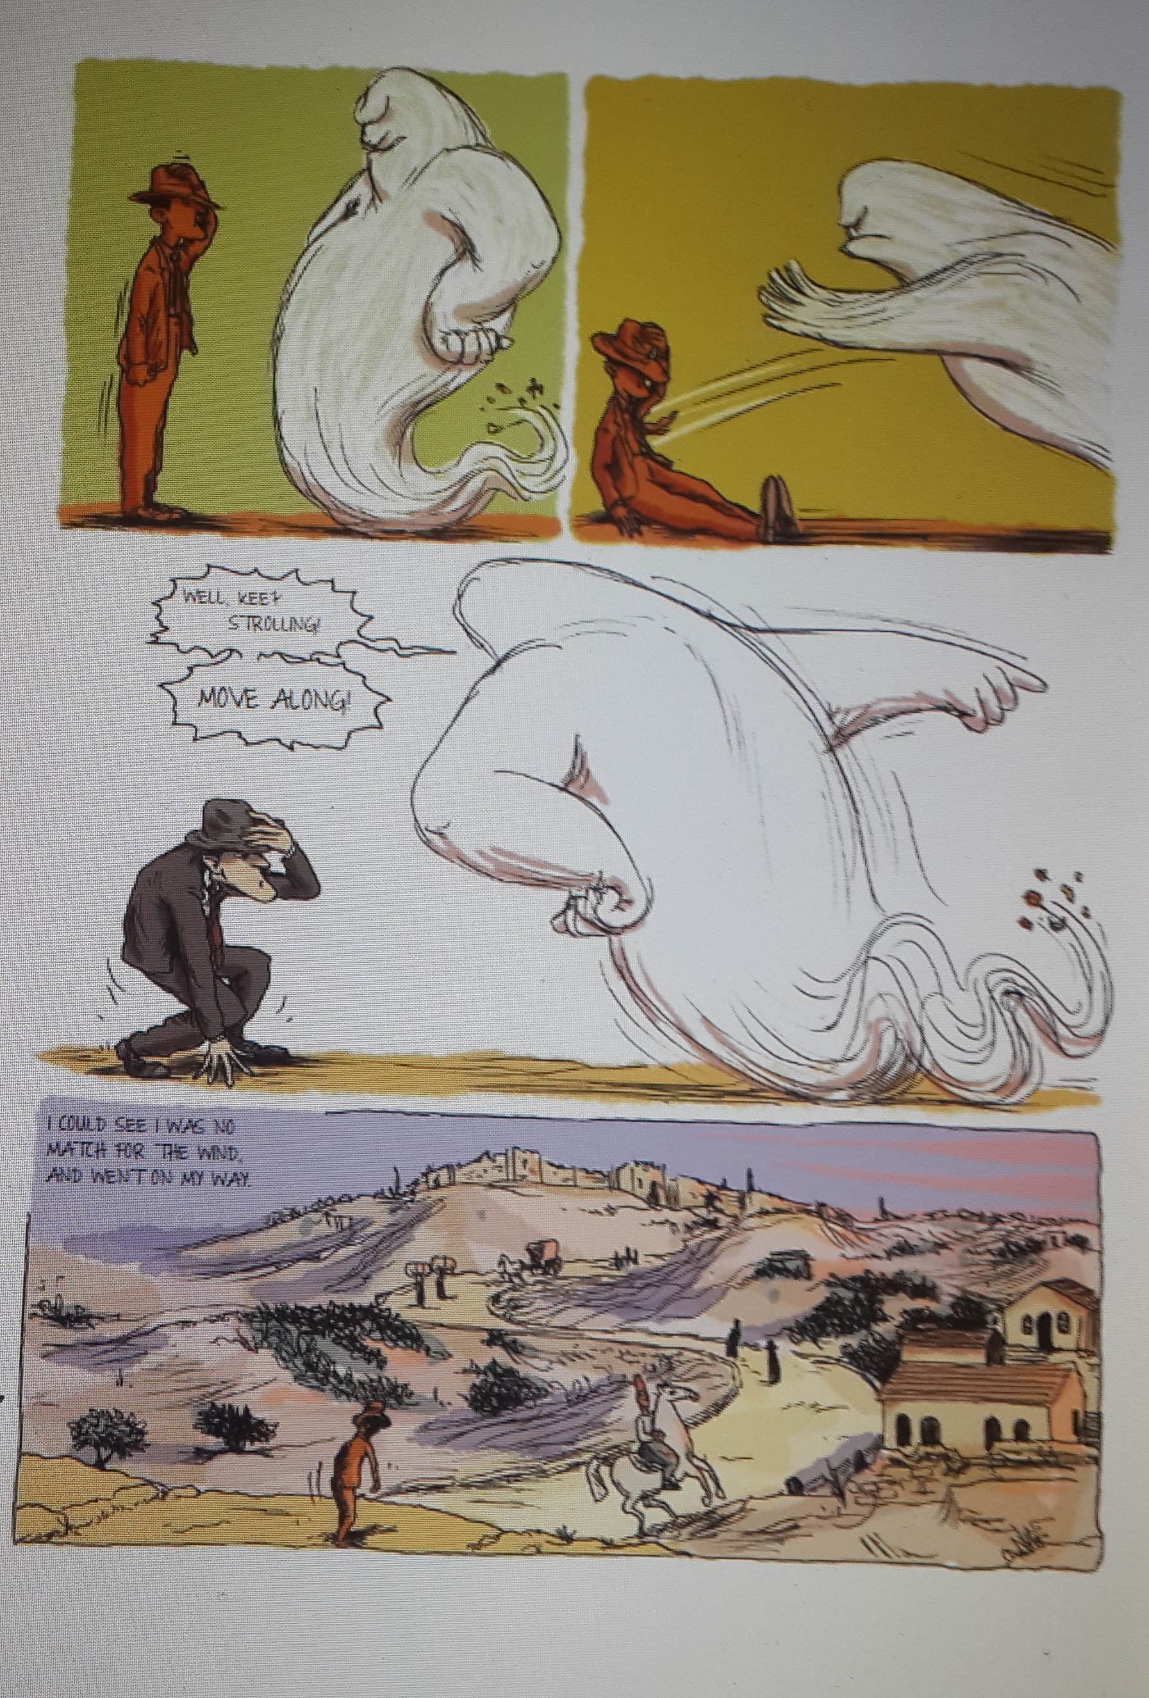
Facing the Walls of the Old City
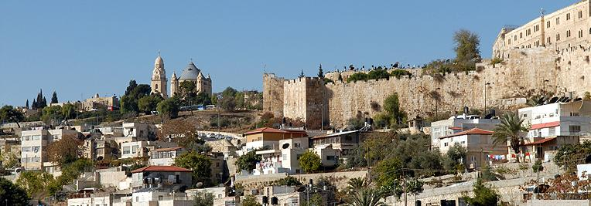
…What a pity, my son, that you do not dwell in the city and don’t see our rebbetzin, long life to her, getting better from hour to hour.
And don’t I live in Jerusalem? Said I to her, Isn’t Nahlat Shiv’ah Jerusalem? Heaven forbid, said Tillie, who says not? On the contrary, Jerusalem is destined in the future to expand on every side even as far as Damascus, yet the eye that has seen Jerusalem all established within the walls cannot accustom itself to viewing anything built beyond the walls of Jerusalem as though it were Jerusalem itself. The whole of Eretz Israel is holy. Not to mention the surroundings of Jerusalem; and yet all within the walls is sanctified in even higher sanctity. I know, my son, I have not said anything you do not know better than I. Then why do I say all this? In order to recount the praises of Jerusalem.
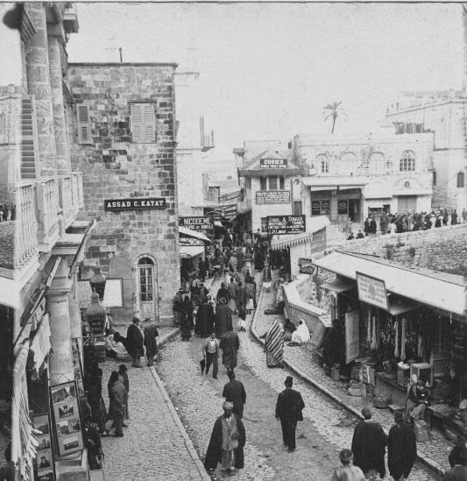
Jerusalem Take Two
I went between the vaulted shops among the goldsmiths, and from there passed to the street of the scents and spices, and from there to the shoemakers and blanket weavers, and from there to the cooks and then to the street of the Jews. Swathe in their rags and tatters the beggars sat, not ready so much as to take their hands out of their wrappings, but glaring at every passer-by who did not put his own hand into his pocket. I had a pocket full of small coins with me, so I went from one beggar to another giving each of them his alms. When I was done I asked where the rebbetzin lived, and they showed me.
I entered one of those courtyards about which any one might well doubt whether a human being indeed lived there, and climbed up six or seven broken steps and reached a warped door. Outside it I stumbled over a cat; inside over a heap of rubbish. A frosty mist was in the air so that I could not see anybody, but I heard an annoyed voice croaking, who’s there? Raising my eyes I saw a kind of iron bed piled with cushions and pillows, and in the middle of the pile a startled and testy old woman.

About Tourists
I. After that came the matter of the tourists. Now you know the tourists, and how they used to laugh at us and the country. But when the all-and – Ever Present made things a little roomier for us in the country, they also began coming to take a look. And when they come they regard us as though we were created only to serve them. Still, there’s one good thing about tourists, that because we show them things we also get to see things.
II. When the tourists left Jerusalem I felt like a person who doesn't know what to do. I tried to go back to my work but couldn’t. So I got up and went to the Old City, and made the rounds of the places I had shown to the tourists. What I saw? What didn’t I see! He who by his goodness renews the work of Creation everyday makes His City anew every hour. New buildings are not built new plants are not planted, yet Jerusalem herself keeps on becoming new. Whenever I enter the City she seems new to me. I do not know in what this novelty consists. Let the great clarifiers come and clarify it for us.
About Scholars I
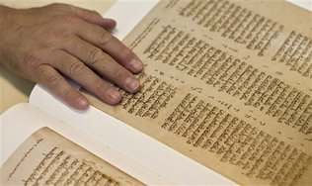
I found the man at home, sitting at his desk. Whether he recognized me or not I don’t know. But since he had hit upon something interesting and novel in connection with his studies just as I was coming in, he told me all about it. From that he went to another interesting and novel item. On leaving I wanted to ask him, who’s that old woman who showed me the way? Her face was all peace, and the warmth in her voice gladdened the heart. But it’s hardly possible to interrupt a sage when he’s busy expounding all his scholarly novella to you.
About Scholars II
This learned sage I have already mentioned came across me and dragged me off to his home, and expounded to me all the novella he had turned up since last he had seen me. We sat as long as we sat, and I asked the questions and he answered; I raised difficulties and he explained them away; I was thick headed and he made matters clear.
How good and pleasant it is to sit before a sage of the Sages of Jerusalem and learn Torah from him! His home is simple like those colors one sees from the window over the mountains of Jerusalem, without palaces and castles upon them. Ever since we were exiled from our land the nations have been coming one after the other, destroying and ruining again and again. Yet the mountains rise in all their majesty, fitted out with embroideries of all colors and glorified with countless ornaments; among them the Mount of Olives, with no forest full of trees, but shrouded with graves of the righteous, who are completely given over to the land, in life and in death.

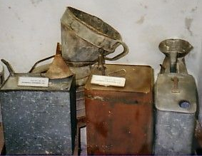
Who is Tehila?
There was an old woman in Jerusalem, nicer than any-body you have ever seen. She was good and wise and meek and charming. The light in her eyes, spoke forbearance and mercy, and the wrinkles in her cheeks, blessings and peace. Were it not that women are not to be compared to angels, I would say that she was just like one of God’s own angels. Another thing about her was that she was spry as a youngster. The only sign of old age in her was the manner of her dress.
I did not know her before I left Jerusalem, but made her acquaintance after I returned. And how is it that I did not know her before? Well, tell me how is it that you don’t know her even now? But it is ordained for every man whom he is to know, and when he is to know him, and how.
How did I get to know her? Once I went to visit one of the wise men of Jerusalem who lived near the Western wall. I couldn’t find his house, but I did find a woman coming along with a kerosene can full of water, and asked her. Come along and I will show you, said she to me; No need to bother, said I to her, just tell me where it is and I will find my way.
At this she smiled and said, why do you mind if it is given to an old woman like me to fulfill a commandment? If it’s a commandment you’re fulfilling, said I, then by all means enjoy the privilege; but give me this can you are holding.
Why, said she smiling, do you want to make the commandment less? I certainly don’t want to make the commandment less, said I, but only to lessen your trouble. It isn’t any trouble at all, said she, but privilege, for the Blessed Holy One has given His creatures the strength to attend to their needs with their own hands.
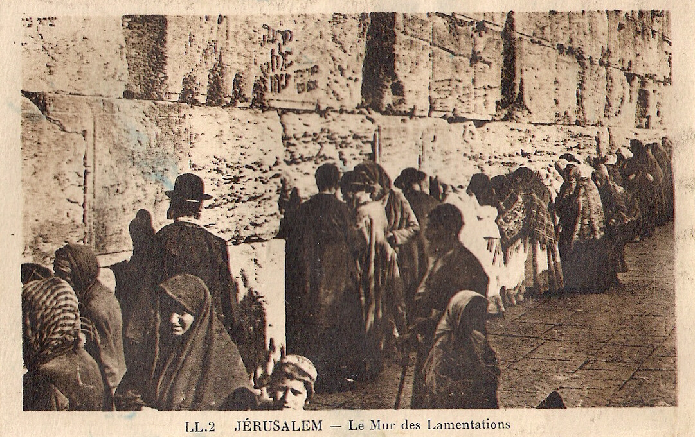
How does Tehila see others?
I found myself a tiny place beside the Wall. Sometimes I stood among the worshipers and sometimes among the wonderers. I wondered about the nations of the world: Not enough that they are hounding us from all countries, but they have to go on hounding us even in our own home.
While I was standing there I was shoved away from my place by one of the Mandatory Police pushing with the riding crop in his hand. What could have upset him to make him so angry? An old woman had brought a little stool with her to sit on. The policeman came at a trot and kicked away the footstool, knocking the woman over. Then he took away the footstool, because she had broken the law made by the Mandatory lawmakers, forbidding a worshiper to bring a seat to the Wall. The people praying saw this and remained silent, for who can argue with someone mightier than he? Came the old woman whom I knew and looked at him. The policeman dropped his eyes and replaced the stool. I approached the old lady and said to her, Your eyes are more powerful than all the promises of England, for England has given us the Balfour Declaration but set her officials over us to nullify it, but you, my old one, just set your eyes upon that wicked one and put naught a his evil purposes.
Don’t speak so, answered she, he’s a good Gentile who saw my anguish and gave the poor woman back her chair.
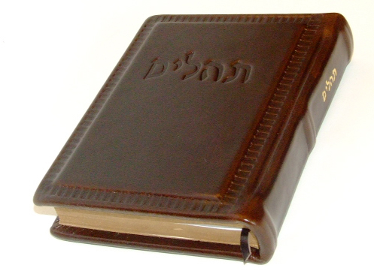
Tehila's Moods
I joined her and we went together. We wound our way from alley to alley and from court to court, and at almost every step she paused to give a piece of sugar to a child or a coin to a beggar, or to ask a man how his wife was and a woman how her husband was. Since you are asking every-body how they are, said I to her, I’ll ask you how you are. Blessed be He and blessed be His Name, she answered, I lack for nothing from Him. The Blessed Holy one gives all His creatures according to their needs, and I, too, am one of His creatures. I ought to give him particular thanks today because He has doubled my portion. Now what is that? I asked her. Day by day, she replied, I complete one day’s reading of the Psalms, but today I completed two days’ readings. But even as she spoke her face grew sad.
You are upset, said I to her. She paused a little while and then replied, Yes, my son, I was happy but am no longer. Even as she spoke her face grew bright again, she raised her eyes aloft and said Bless God who has removed my grief from me. Why said I, were you happy and then sad, and now you are happy again? If you won’t be vexed, said she fondly, you are a good man, said she, and have quoted me a good verse, so I shall not withhold a good thing from you. You ask why I was happy and why I was sad, and why I am happy once again. Certainly you know just as well as I do that all man’s deeds from his birth to his death are portioned out to him; and even the number of times that a man should recite Psalms. But the choice lies with him how many Psalms he should say each day. Some men are worthy of completing the entire book of Psalms every day, while some merit the completion of one of the Five Books or the daily portion each day. I have made it my practice to recite a day’s portion each day. Today I went on and completed two day portions. When I thought this over I felt sad, for maybe I am no longer necessary in the world and they want to be done with me and are urging me to finish my share and complete my portion. Yet it is good to give thanks to the Lord, and if I die I cannot say even a single Psalm, not so much as a single word. The Blessed Holy One saw my grief and showed me His wondrous loving-kindness, so that I should know that such is His Blessed Will. And if the Name wishes to slay me, so who I am to grieve? God took my sorrow away at once. Blessed be He and blessed be His Name.
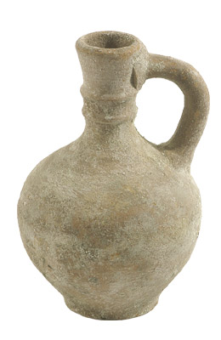
Tehila's Bequest
I took out a fountain pen. She looked at it and said, you carry a pen about with you like someone carrying a spoon about so that when something to eat comes his way the spoon is ready and waiting. And the food, said I, is inside the spoon; and I explained how the pen worked. She took it in her hand and said, you say there is ink in it but I can’t see a drop. I explained it to her again. In that case, said she, there is nothing to the charge they make against this generation that all the innovations they have produced are only harmful. Why, they have invented a portable oven and such a pen as this too, and maybe they have invented other things for the people’s benefit. The more you live the more you see. In any case, take this quill which I myself have prepared, and dip it in this ink. I don’t doubt your pen, but I want my letter to be written by my own. Here is a sheet of paper, first-grade paper which I have kept from bygone days, from the time when they used to make good paper. I have had it with me for more than seventy years, and it’s still as good as new. One thing more I ask of you, write in the square letters of the prayer book, or in the Torah script. You can rely on a scribe that if he has not yet been privileged to write a Torah scroll, he has certainly written a scroll of Esther.
*********************************************************************************
What brings you here? Asked the older one. To fulfill the contract, she answered. You have come to fulfill the contract, said he, and we think that the time has come to cancel it. What are you saying? Exclaimed Tehilla startled.
Why, said he, surely you have already withdrawn from the Society of Diers. Smiling at his joke he turned to me and said, Tehilla, may her days and years be lengthened, has the practice of coming year after year to confirm the bill of sale for her place on the Mount of Olives. So it was last year and so two years ago and three years ago and ten and twenty and thirty years ago, and so will she keep on doing until the Redeemer comes. The redeemer will come, said Tehilla, he will come indeed, and may he come speedily. But I shall not bother you anymore. Can you possibly be going to a kvutza, asked the clerk wonderingly, like those young girls whom they call halutzot. I am not going to any kvutza, said Tehilla. I am going to my own place.
Are you going back abroad? Asked the clerk. From this land I am not going back, said Tehilla, I am returning to the place from which I come; as it is written, “And unto the dust thou shalt return”

