**Echoes of the Holocaust in Modern Israeli**

**Literature**

**With**

**Dr Rachel Korazim**

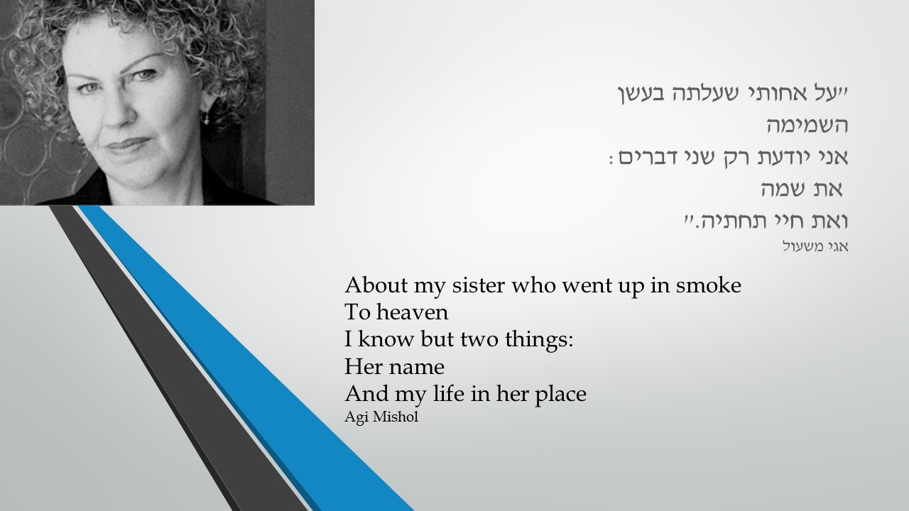

# WRITTEN IN PENCIL IN THE SEALED CAR

**By Dan Pagis**

Here in this convoy

I, Eve,

With my son Abel

If you see my big son

Cain son of Adam

Tell him that I am

# THE CAMP INMATE’S SHIRT

**BY Avner Trainin**

And his brothers did not envy him

His striped shirt

In which they too were clothed

When they were driven off the rails

He did not dream, nor did he interpret

Neither did he rise from the sheaf

And a goat kid was not diminished

When the shirt was dipped in blood

And their father did not recognize it

Because the children of his old age were many He merely murmured “A wild beast” And never saw them again.

## SEE UNDER: LOVE

**David Grossman**

**MOMIK**

It was like this, a few months after Grandma Henny was buried in her grave, Momik got a new grandfather. This grandfather arrived in the Hebrew month of Shebat in the year 5317 of the Creation, which is 1959 by the other calendar, not through the special radio program *Greetings from New Immigrants* which Momik had to listen to every day at lunch between 1:20 and 1:30, keeping his ears open in case they called out one of the names on the list Papa wrote down for him on a piece of paper; no, Grandfather arrived in a blue Mogen David ambulance that pulled up in front of Bella Marcus’s café-grocery store in the middle of a rainstorm, and this big fat man, dark but like us, not a shvartzer, stepped out and asked Bella if she knew anyone around here called Newman, and Bella got scared and wiped her hands on her apron and said, Yes, yes, did something happen, God forbid? And the man said, don’t get excited, lady, nothing happened, what can happen. no, I bring them a relative, see, and he thumbed backward over his shoulder at the ambulance in the street which seemed empty and quiet, and Bella suddenly turned as white as this wall and everybody knows she isn’t scared of anything, but she wouldn’t go anywhere near the ambulance, she only edged closer to Momik, who was doing Bible homework at one of the little tables, and said, “Vay iz mir,” a relative now? And the man said, “Nu, lady we don’t got all day, so if you know these people maybe you can tell me where they are, because is nobody home.” He talked broken Hebrew like that even though he didn’t look so much like a newcomer, and Bella said to him, Sure, what did you expect, sure nobody’s home, because these people are not parasites, these people work plenty hard for their bread, morning to night they’re working in the lottery booth two streets down, and this little boy here, he’s theirs, so just you wait a minute, mister, I’m going to run get them. and she ran out with her apron still on and then the man winked at Momik, and when Momik didn’t do anything because he knows how you’re supposed to behave around strangers, the man shrugged his shoulders and started reading the newspaper Bella left there and he said to the air, Even with this rain we’re having, seems like it’s going to be a drought year, yeah, that’s all we need.

## Once There Was a Family

## Lysie Doron

In the early 50’s a new land came into being in the State of Israel. The land of Here.

It is populated by an extinct people from the land of There.

Its inhabitants came unwillingly. Their belongings consist of a strange language, odd customs, memories and nightmares.

After the annihilation of the land of There, they commanded themselves to undertake an act of creation and established a new world.

Helena, my mother, lived in the world of Here, after dying in the Second World War. Here she raised me by herself.

In the early 90’s, after my mother died for the second time, those who still remained in the land of Here came to pay their last respects and to resurrect those who were not.

And this land, which has been dying for many years, came back to life:

For seven days only an unknown land existed once again. The land that was for me both homeland and family.

And this is its story.

1950-1990

**Autumn 1990**

**Friday afternoon**

After the funeral I returned to my mother’s house.

Nobody had been there for nearly a year.

Since my mother went to hospital the iron gate was locked, there was no light and the shutters were damaged. The two rooms, hall, kitchen, bathroom and veranda of the old house were deserted.

When I opened the door a smell of mold greeted me.

A box of matches lay on the cabinet in the hallway. Next to it, as always, was the *ner neshama*, the memorial candle for one of mother’s departed. I lit the wick and opened the shutter. The dark house was filled with blinding light.

The candlelight recalled Shabbat evenings of my childhood: gleaming silver candlesticks, a white tablecloth covered with tiny mounds of frozen drops of wax, a sweet c*hallah* in the center of the old table, red *Kiddush* wine, two porcelain dishes – and, seated at the table, only a mother and daughter.

My mother filled the rooms of the house. Her voice could be heard, her brown eyes would shine, the aroma of soup and cake wafted from the kitchen.

I remembered Fridays, when she spread her hands before the Shabbat candles, closed her lips, closed her eyes and stood silently. That’s how she always stood before the candles, not blessing, not praying. Her legs were swollen and heavy, and her travails were etched in her many wrinkles – she was prematurely aged. Only the palms of her hands, spread over the small flames, bore testimony to the beauty that might have been.

The palms of her hands were delicate, smooth and tender, with long, slender fingers. The palms of a lady. Only one finger, the little finger, was bent and frozen.

“Why is your finger that way?” I wondered silently when I was young. Aloud, I asked: “Mother, where is your little finger?”

“Hiding in the palm of my hand,” she replied, and I laughed.

When I was older I dared to ask again: “Mother, what happened to your little finger?”

“It’s a souvenir from over there,” she replied. “From the time when God went away and departed from the world.” She didn’t explain further.

After that I stopped asking.

This evening I saw the beautiful palms of my mother Helena’s hands. I remembered people’s glances catching the folded finger, children’s whispers: “Look, look, the woman without a little finger,” and mother telling me proudly: “Alone, with nine fingers, I built a family here.”

**Silences Itamar Yaoz Kest**

To my cousin Elizabeth

The numbers on her forearm had crumbled already

Like the tattoos on the sailors’ arms

Thirty five years of a self-imposed silence verdict

On the story of the numbers on her forearm starting with an A

So that she could live the here and now

In the shade of the sea, the home, the kids

If she gave herself away sometimes

It was just like a casual move of the sleeve;

And now five abandoned numbers, in my brain, refuse

To return to the silence of the multiplication table.

**שתיקות – איתמר יעוז קסט**

לבת דודי אליזבט ז"ל

כְּבָר הִתְפוֹררוּ הַסְפָרוֹת עַל זְרוֹעָהּ

כְּמוֹ כְּתוֹבוֹת-הַקַעֲקַע שֶׁעַל זְרוֹעוֹת הַמָּלָּחִים;

שְׁלוֹשִׁים וְחָמֵש שָׁנָה גָזְרָה אֵלֶם

עַל סִפּוּר הַסְפָרוֹת שֶׁעַל זְרוֹעָהּ, הַמָתְחִיל ב-A

לְמַעַן תּוּכַל לִחְיוֹת אֶת הָכָּאן-וְהָעַכְשָו

בְּצֵל הַיָם, הַבַּית וְהַיְלָדִים,

וְאִם הִסְגִירָה עַצְמָה מִדֵי פָּעָם

הָיָה זֶה רָק כְּעֵין הֶסֵּט מִקְרִי שֶׁל הַשָרווּל;

וְכָעֵת חָמֵש סְפָרוֹת נְטוּשׁוֹת מְסָרְבוֹת בְּמוֹחִי

לָשוּב אֶל שְׁתִּיקַת לוּח הָכֶּפֶל