**In The Land of Oz III**

**A Tale of Love and Darkness**

Home - Vilna

School – Zelda

Jerusalem and Tel Aviv

Values

**The Same Sea**

**Jews and Words**

School – Zelda

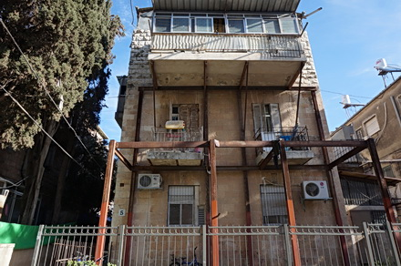Teacher Zelda talked so softly that if we wanted to hear what she was saying we not only had to stop talking, we had to lean forward on our desks. Consequently we spent the whole morning leaning forward, because we did not want to miss a word. Everything that Teacher Zelda said was enchanting and rather unexpected. It was as if we learnt another language from her, not very different from Hebrew and yet distinctive and touching. She would call stars the ‘stars of heaven’, the abyss was ‘the mighty abyss, and she spoke of ‘turbid rivers’ and ‘nocturnal deserts’. If you said something in class that she liked, Teacher Zelda would point towards you and say softly: ‘Look, all of you, there’s a child who’s flooded with light.’ If one of the girls was daydreaming, Teacher Zelda explained to us that just as nobody can be blamed for being unable to sleep, so you couldn’t hold Noa responsible for being unable to stay awake at times.

She was my first love. An unmarried woman in her thirties, Teacher Zelda, Miss Schneersohn. I was not quite eight and she swept me away, she set some kind of inner metronome in motion that had not stirred before and has not stopped since. When I woke up in the morning I conjured up her image even before my eyes were open. I dressed and ate my breakfast in a flash, eager to finish, zip up, close, pick up, run straight to her. My head melted with the effort to prepare something new and interesting for her every day so that I would get the light of her look and so that she would point to me and say, ‘Look, there’s a boy among us this morning who’s flooded with light.’

EACH OF US HAS A NAME – ZELDA

Each of us has a name,  
given to us by God,  
and given to us by our father  
and mother.  
Each of us has a name,  
given to us by our stature  
and our way of smiling,  
and given to us by our clothes.  
Each of us has a name,  
given to us by the mountains,  
and given to us by our walls.  
Each of us has a name,  
given to us by the planets,  
and given to us by our neighbors. -

Each of us has a name,  
given to us by our sins,  
and given to us by our longing.  
Each of us has a name,  
given to us by our enemies,  
and given to us by our love.  
Each of us has a name,  
given to us by our fast days,  
and given to us by our craft.  
Each of us has a name,  
given to us by the seasons of the year,  
and given to us by our blindness.  
Each of us has a name,  
given to us by the sea,  
and given to us by our death.

Homelands - Vilna

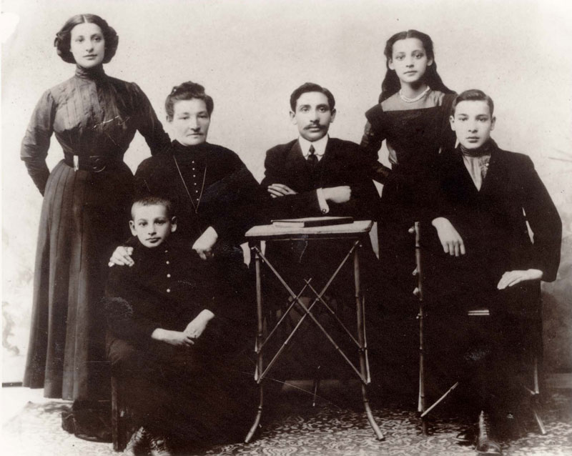 Their elder son, David, that committed and conscientious Europhile, stayed in Vilna. There, at a very early age, and despite being Jewish, he was appointed to a teaching position in literature at the University. He had no doubt set his heart on the glorious career of Uncle Joseph, just as my father did all his life. There in Vilna he would marry a young woman called Malka, and there, in 1938, his son Daniel would be born. I never saw this son, born a year and a half before me, nor have I ever managed to find a photograph of him. There are only some postcards and a few letters left, written in Polish by Aunt Malka (Macia).….

Little Daniel Klaussner would live for less than three years. Soon they would come and kill him to protect ‘Europe’ from him, to prevent in advance Hitler’s ‘nightmare vision of the seduction of hundreds and thousands of girls by repulsive, bandy-legged Jew bastards . . . But Uncle David thought otherwise: he despised and dismissed such hateful views as these, refused to consider solemn Catholic anti-Semitism echoing among the stone vaults of high cathedrals, or coldly lethal Protestant anti-Semitism, German racialism, Austrian murderousness, Polish Jew-hatred, Lithuanian, Hungarian or French cruelty, Ukrainian, Romanian, Russian and Croatian love of pogroms, Belgian, Dutch, British, Irish and Scandinavian mistrust of Jews. All these seemed to him an obscure relic of savage, ignorant aeons, remains of yesteryear, whose time was up. A specialist in comparative literature, for him the literatures of Europe were a spiritual homeland. He did not see why he should leave where he was and immigrate to Western Asia, a place that was strange and alien, just to please ignorant anti-Semites and narrow-minded nationalist thugs. So he stayed at his post, flying the flag of progress, culture, art, and spirit without frontiers, until the Nazis came to Vilna: culture-loving Jews, intellectuals and cosmopolitans were not to their taste, and so they murdered David, Malka and my little cousin Daniel, who was nicknamed Danush or Danushek; in a penultimate letter, dated 15.12.40, his parents wrote that ‘he has recently started walking . . . and he has an excellent memory’. Uncle David saw himself as a child of his time: a distinguished, multicultural, multi-lingual, fluent, enlightened European and a decidedly modern man. He despised prejudices and ethnic hatreds, and he was resolved never to give in to low-brow racialists, chauvinists, demagogues and benighted, prejudice-ridden anti-Semites, whose raucous voices promised ‘death to the Jews’ and barked at him from the walls: ‘Yids, go to Palestine!’ To Palestine? Definitely not: a man of his stamp would not take his young bride and infant son, defect from the front line and run away to hide from the violence of a noisy rabble in some drought-stricken Levantine province, where a few desperate Jews tried their hand at establishing a segregationist armed nationhood that, ironically, they had apparently learned from the worst of their foes. No, he would definitely stay here in Vilna, at his post, in one of the most vital forward trenches of that rational, broad-minded, tolerant and liberal European enlightenment that was now fighting for its existence against the waves of barbarism that were threatening to engulf it. Here he would stand, for he could do no other. To the end.

*In 1947 the Tel Aviv publisher Joshua Chachik brought out my father’s first book, The Novella in Hebrew Literature, from its origins to the end of the Haskalah*…. *on a separate page, after the title page, my father dedicated his book to the memory of his brother David:*

***To my first teacher of literary history –***

***My only brother***

***David***

***Whom I lost in the darkness of exile.***

***Where art thou?***

2. Jerusalem and Tel Aviv

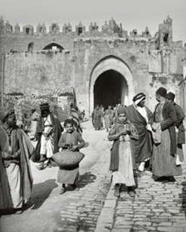In Jerusalem people always walked rather like mourners at a funeral, or latecomers at a concert. First they put down the tip of their shoe and tested the ground. Then, once they had lowered their foot they were in no hurry to move it: we had waited two thousand years to gain a foothold in Jerusalem, and were unwilling to give it up. If we picked up our foot someone else might come along and snatch our little strip of land. On the other hand, once you have lifted your foot, do not be in a hurry to put it down again: who can tell what menacing nest of vipers you might step on. For thousands of years we have paid with our blood for our impetuousness, time and time again we have fallen into the hands of our enemies because we put our feet down without looking where we were putting them. That, more or less, was the way people walked in Jerusalem. But Tel Aviv – wow! The whole city was one big grasshopper. The people leaped by, so did the houses, the streets, the squares, the sea breeze, the sand, the avenues, and even the clouds in the sky.

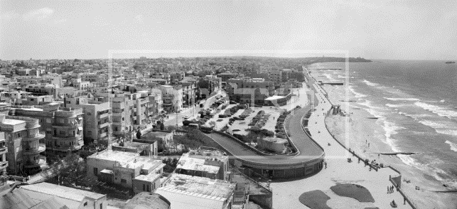People in Jerusalem talked about Tel Aviv with envy and pride, with admiration, but almost confidentially: as though the city were some kind of crucial secret project of the Jewish people that it was best not to talk about too much – after all walls have ears, spies and enemy agents could be lurking round every corner.

Homeland – Tel Aviv

Tel Aviv: row after row of square, white-painted houses, quite unlike houses in a town or a village in Poland or Ukraine, quite unlike Rovno or Warsaw or Trieste, but very like the pictures on the wall in every classroom at Tarbuth, and the drawings and photographs that our teacher Menahem Gelehrter used to show us. So that I was both surprised and not surprised. I can’t describe how all at once the joy rose up in my throat, suddenly all I wanted to do was to shout and sing; this is mine! All mine! It really is all mine! It’s a funny thing, I’d never experienced such a strong feeling before in my life, of belonging, of ownership, if you know what I mean, not in our house, our orchard, the flour mill, never. Never in my life, either before that morning or after it, have I known that kind of joy: at long last this would be my home, at long last here I’d be able to draw my curtains and forget about the neighbors and do exactly as I pleased. Here I didn’t need to be on my best behavior the whole time, I didn’t have to be shy because of anyone, I didn’t have to worry about what the peasants would think of us or what the priests would say or what the intelligentsia would feel, I didn’t have to try to make a good impression on the gentiles. Even when we bought our first flat, in Holon, or this one in Wessely Street, I didn’t feel so strongly how good it felt to own your own home. And that was the feeling that filled me at maybe seven in the morning, looking out at a city I’d never even been to, and a land where I’d never set foot, and funny little houses the like of which I’d never seen before in my life! I don’t suppose you can understand this.

* Values

We had an iron rule that one should never buy anything imported, anything foreign, if it was possible to buy a locally-made equivalent. Still, when we went to Mr Auster’s grocery shop, on the corner of Obadiah and Amos Streets, we had to choose between kibbutz cheese, made by the Jewish co-operative Tnuva, and Arab cheese: did Arab cheese from the nearby village, Lifta, count as home-made or imported produce? Tricky. True, the Arab cheese was just a little bit cheaper. But if you bought Arab cheese, weren’t you being a traitor to Zionism? Somewhere, in some kibbutz or moshav, in the Jezreel Valley or the hills of Galilee, an overworked pioneer girl was sitting, with tears in her eyes perhaps, packing this Hebrew cheese for us – how could we turn our backs on her and buy alien cheese? Did we have the heart? On the other hand, if we boycotted the produce of our Arab neighbours, we would be deepening and perpetuating the hatred between our two peoples. And we would be partly responsible for any blood that was shed, heaven forbid. Surely the humble Arab fellah, a simple, honest tiller of the soil, whose soul was still undefiled by the miasma of town life, was nothing more nor less than the dusky brother of the simple, noble-hearted mujik in the stories of Tolstoy! Could we be so heartless as to turn our backs on his rustic cheese? Could we be so cruel as to punish him? What for? Because the deceitful British and the corrupt effendis had set him against us? No. This time we would definitely buy the cheese from the Arab village, which incidentally really did taste better than the Tnuva cheese, and cost a little less into the bargain. But still, on the third hand, what if the Arab cheese wasn’t too clean? Who knew what the dairies were like there? What if it turned out, too late, that their cheese was full of germs? Germs were one of our worst nightmares. They were like antisemitism: you never actually managed to set eyes on an antisemite or a germ, but you knew very well that they were lying in wait for you on every side, out of sight. Actually, it was not true that none of us had ever set eyes on a germ: I had. I used to stare for a long time very intently at a piece of old cheese, until I suddenly began to see thousands of tiny squirming things. Like gravity in Jerusalem, which was much stronger then than now, the germs too were much bigger and stronger. I saw them. A little argument used to break out among the customers in Mr Auster’s grocery shop: to buy or not to buy Arab cheese? On the one hand, ‘charity begins at home’, so it was our duty to buy Tnuva cheese only; on the other hand, ‘one law shall there be for you and for the stranger in your midst’, so we should sometimes buy the cheese of our Arab neighbors, ‘for you were strangers in the land of Egypt’. And anyway, imagine the contempt with which Tolstoy would regard anyone who would buy one kind of cheese and not another simply because of a difference of religion, nationality or race! What of universal values? Humanism? The brotherhood of man? And yet, how pathetic, how weak, how petty-minded, to buy Arab cheese simply because it cost a couple of mils less, instead of cheese made by the pioneers, who worked their backs off for our benefit! Shame! Shame and disgrace! Either way, shame and disgrace! The whole of life was full of such shame and disgrace.

The Same Sea

**A Cat**

A CAT Not far from the sea, Mr Albert Danon lives in Amirim Street, alone. He is fond of olives and feta; a mild accountant, he lost his wife not long ago. Nadia Danon died one morning of ovarian cancer, leaving some clothes, a dressing table, some finely embroidered tablemats. Their only son, Enrico David, has gone off mountaineering in Tibet. Here in Bat Yam the summer morning is hot and clammy but on those mountains night is falling. Mist is swirling low in the ravines. A needle-sharp wind howls as though alive, and the fading light looks more and more like a nasty dream. At this point the track forks: one way is steep, the other gently sloping.

Not a trace on the map of the fork in the track. And as the evening darkens and the wind lashes him with sharp hailstones, Rico has to guess whether to take the shorter or the easier way down. Either way, Mr. Danon will get up now and switch off his computer. He will go and stand by the window. Outside in the yard on the wall is a cat. It has spotted a lizard. It will not let go.

Oz, Amos. The Same Sea (p. 1). Random House. Kindle Edition.

**Back in Bat Yam his Father Upbraids him**

Rebellious son. Stubborn son.

I am asleep but my heart is awake.

My heart is awake and makes lament,

The smell of my son is like the smell of a harlot.

There is no peace for my bones on account of your wanderings. How long?

**But his Mother Defends Him**

His mother says:

My view is different.

Wandering is fitting for those who have lost their way.

Kiss the feet my son

Of the woman Maria

Whose womb, for an instant, returned you to mine.

Oz, Amos. The Same Sea (p. 31). Random House. Kindle Edition.

**No Butterflies and No Tortoise**

The forecast, that had promised a chance of snow on high ground,

Had not kept its promise.

But Nadia, who had promised nothing, appeared at his door one Saturday morning,

In a light-colored frock with a red scarf round her neck,

Somewhere between a girl and a woman.

Did I surprise you? Are you free?

(Am I free? Oh, painfully free.

His heart dissolved in bashful glee.

Nadia. Has come. To visit. Me.)

Albert was renting a room from a childless couple in old Bat Yam.

They were away for the weekend.

The flat was all his.

He sat Nadia down on his bed and went to the kitchen to slice some black bread,

And came back bearing a tray with a choice of feta or honey.

He paced round the room,

Then returned to the kitchen,

And chopped some tomatoes to make a salad so fine and well-seasoned as though this would convince her that he was right.

He would not let her lift a finger to help him.

He made an omelet.

Put the kettle on. Like a man in his element.

This surprised her, because previously whenever they went out together to a café or the cinema Albert had seemed so hesitant and unassertive.

And now it emerged that at home he did precisely what he wanted,

And what he wanted was to do everything himself.

She touched his hand with her fingertip: thank you.

It’s nice here. Coffee. Biscuits.

But how do you start on love on a rainy Saturday morning like this,

In a shabby room in old Bat Yam in the mid-Sixties?

(In the headlines in the paper on the kitchen table Nasser threatened and Eshkol warned of the risk of escalation.)

The light flickered.

The room was small.

Nadia sat.

Albert faced her.

Neither of them knew how to begin.

The would-be lover was a shy young man,

Who had only ever dreamed of sleeping with a woman.

He dreaded yet wanted it;

He wanted it but was deterred by a faint fear of bodily embarrassments.

His would-be partner,

a reserved divorcee,

Lived in a room on a roof,

Sewed for a living,

Her past was somewhat conventional.

She was no hind and he was no young hart.

How and with what do you begin to love?

Nadia sat. Albert stood.

Outside it was raining again, the rain getting heavier,

Of dull grey shutters along the empty wet street;

Hammering on overturned dustbins, polishing the panes in the tight-shut windows,

Pouring down on rooftops,

On forests of aerials trembling in the freezing wind

That beat on zinc tubs hanging on grilles of kitchen balconies.

And the gutters grunted and choked like an old man sleeping fitfully.

How do you start love now?

Nadia stood. Albert sat.

Through the wall from the next-door flat came the Saturday morning program on the radio.

A musical quiz. Nadia is here but where am I?

He tried to tell her some news from the office,

Not to break the thread of the conversation.

But the thread was no thread.

She was waiting and he was waiting

For whatever would come at the end of the thread.

What would come? And who would make it come?

She was embarrassed. So was he.

He kept on and on trying to explain something in economics.

Instead of words like credit side, debit side,

Nadia heard, my sister, my bride.

And when he spoke of bulls and bears

She translated, you have doves’ eyes.

While he was talking she reached for a cushion,

And Albert trembled because on the way the warmth of her breast touched his back.

It’s up to me to overcome his fear.

What would a really experienced woman do now in my place?

She cut in: apparently, all of a sudden, she had a speck of dust in her eye.

Or a fly. He bent over to get a good look.

Now his face was close to her brow,

She could clasp his temples with her hands,

And at last lower his lips for a pleasing, teasing first kiss.

Two weeks later, in her room on the roof,

Between two rain showers, he asked for her hand.

He did not say, be my wife, but instead:

If you’ll marry me then I’ll marry you.

Because it was Nadia’s second marriage they had a small, intimate party,

At her brother and sister-in-law’s home,

With a handful of relations and a few friends,

And the elderly couple in whose flat Albert lodged.

After the ceremony and the party they took a taxi to the Sharon Hotel.

Albert undid the straining hooks one by one down the back of her wedding dress.

Then the bride turned out the light and they both undressed modestly,

in total darkness, on opposite sides of the bed.

They groped their way towards each other.

She sensed she would have to teach him:

After all I presumably know better than he does.

It turned out however that shy Albert could teach her something she neither knew nor imagined: the broad, flowing surge of joy of one who was shy as long as the light was on but in the pitch dark was insatiable.

In the dark he entered into his own element.

No butterflies now and no tortoise at all,

But like a hart panting for water or a swallow for its nest.

His chest to her back, and belly to belly, horse and his rider

And into every breach.

**Ditta Offers**

Give me five minutes to try to sort out this screwed-up business. People are constantly being ditched. Here in Greater Tel Aviv for example I bet the daily total of ditchings is not far short of the figure for burglaries. In New York the statistics must be even higher. Your mother killed herself and left you quite shattered. And haven’t you yourself ditched any number of women? Who in turn had ditched whoever they ditched in favor of you, and those ditched guys had certainly left some wounded Ditchinka lying on the battlefield. It’s all a chain reaction. OK, I’m not saying, I admit being ditched by your own parents is different, it bleeds for longer. Specially a mother. And you an only son. But how long for? Your whole life? The way I see it being in mourning for your mother for forty-five years is pretty ridiculous. It’s more than ridiculous: it’s insulting to other women. Your wife, for instance. Or your daughters. I find it a turn-off myself. Why don’t you try and see it my way for a moment: I’m twenty-six and you’ll soon be sixty, a middle-aged orphan who goes knocking on women’s doors and guess what he’s come to beg for. The fact that before my parents were even born your mother called you Amek isn’t a life sentence. It’s high time you gave her the push. Just the way she chucked you. Let her wander round her forests at night without you. Let her find herself some other sucker. It’s true it’s not easy to ditch your own mother, so why don’t you stick her in some other scene, not in a forest,

let’s say in a lake: cast her as the Loch Ness monster, which as everyone knows may be down there or may not exist, but one thing is certain, whatever you see or think you see on the surface isn’t the monster, it’s just a hoax or an illusion.

Oz, Amos. The Same Sea (p. 134). Random House. Kindle Edition.

Jews and Words

At this early stage we need to say loud and clear what kind of Jews we are. Both of us are secular Jewish Israelis. This self-definition carries several significances. First, we do not believe in God. Second, Hebrew is our mother tongue. Third, our Jewish identity is not faith-powered. We have been reading Hebrew and non-Hebrew Jewish texts all our lives; they are our cultural and intellectual gateways to the world. Yet there is not a religious bone in our bodies. Fourth, we now live in a cultural climate—in the modern and secular part of Israeli society—that increasingly identifies Bible quoting, Talmudic reference, and even a mere interest in the Jewish past, as a politically colored inclination, at best atavistic, at worst nationalist and triumphalist. This current liberal withdrawal from most things Jewish has many reasons, some of them understandable; but it is misguided. What does secularism mean to Israeli Jews? Evidently more than it means to other modern nonbelievers. From nineteenth-century Haskalah thinkers to latter-day Hebrew authors, Jewish secularity has furnished an ever-growing bookshelf and an ever-expanding space for creative thought. Here is just one nutshell, from an essay titled “The Courage to Be Secular” by Yizhar Smilansky, the great Israeli writer who signed his books with the pseudonym Samech Yizhar: Secularism is not permissiveness, nor is it lawless chaos. It does not reject tradition, and it does not turn its back on culture, its impact and its successes. Such accusations are little more than cheap demagoguery. Secularism is a different understanding of man and the world, a non-religious understanding. Man may very well feel the need, from time to time, to search for God. The nature of that search is unimportant. There are no ready-made answers, or ready-made indulgences, pre-packaged and ready to use. And the answers themselves are traps: give up your freedom in order to gain tranquility. God’s name is tranquility. But the tranquility will dissipate and freedom will be wasted. What then? Self-conscious seculars seek not tranquility but intellectual restlessness, and love questions better than answers. To secular Jews like ourselves, the Hebrew Bible is a magnificent human creation. Solely human. We love it and we question it. Some modern archeologists tell us that the scriptural Israelite kingdom was an insignificant dwarf in terms of material culture. For example, the biblical portrayal of Solomon’s great edifices is a later political fabrication. Other scholars cast doubt on all manner of continuity between ancient Hebrews and present-day Jews. Perhaps this is what Amichai meant when he said we are “not even an archaeological people.” But each of these scholarly approaches, whether factually right or wrong, is simply irrelevant for readers like us. Our kind of Bible requires neither divine origin nor material proof, and our claim to it has nothing to do with our chromosomes. The Tanach, the Bible in its original Hebrew, is breathtaking. Do we “understand” it to the last syllable? Obviously not. Even proficient speakers of Modern Hebrew probably misconstrue the original meanings of many biblical words, because their role in our vocabulary differs significantly from what they stood for in Ancient Hebrew. Take this exquisite image from Psalms 104:17, “Wherein the birds make their nests, hassida broshim beiyta.” חֲסִידָה בְּרוֹשִׁים בֵּיתָהּTo a present-day Israeli ear, these three words mean “the stork makes its home in the cypress trees.” Makes you reflect, by the way, on the winsome frugality of Ancient Hebrew, which can often pull off a three-word phrase that requires three times that number in English translation. And how colorful and flavorful is each of the three words, all nouns, brimming with meaning! Anyway, back to our main point. You see, in Israel today storks don’t make their homes on cypresses. Storks very rarely nest here anyhow, and when they settle down in their thousands for a night’s rest en route to Europe or to Africa, those needle-shaped cypresses are not their obvious choice. So we must be getting it wrong; either the hassida is not a stork, or the brash is not a cypress. Never mind. The phrase is lovely, and we know it is about a tree and a bird, part of a great praise for God’s creation, or—if you prefer—for the beauty of nature. Psalm 104 gives its Hebrew reader the broad imagery, the dense and fine-tuned delight that might be compared to the magic of a Walt Whitman poem. We don’t know whether it does the same in translation. The Bible is thus outliving its status as a holy writ. Its splendor as literature transcends both scientific dissection and devotional reading. It moves and excites in ways comparable to the great literary oeuvres, sometimes Homer, sometimes Shakespeare, sometimes Dostoevsky. But its historical leverage is different from that of these opuses. Granted that other great poems may have inaugurated religions, no other work of literature so effectively carved a legal codex, so convincingly laid out a social ethic. It is also, of course, a book that gave birth to innumerable other books. As though the Bible itself harked and heeded the command it attributes to God, “go forth and multiply.” So even if the scientists and critics are right, and ancient Israel erected no palaces and witnessed

Oz, Amos. Jews and Words (Posen Library of Jewish Culture and Civilization) (pp. 4-6). Yale University Press. Kindle Edition.