Messages from Sinai & Learnings from Auschwitz

Introduction
You Mustn't Show Weakness Yehuda Amichai 2-3
Learning from Auschwitz
Kodesh Ha’ Kodashim Uri Tzvi Greenberg 4-7
I Was Not There Gil Nativ 8
The Day of Commemoration and the Rebels Nathan Alterman 9-10
Facing the Glass Booth Haim Gouri 11-12
Who Michal Govrin 14-15

Messages from Sinai
It is Possible Giora Fischer 15
My Father Was God Yehuda Amichai 16

You Must Not Show Weakness – Yehuda Amichai
You mustn't show weakness
and you've got to have a tan.
But sometimes I feel like the thin veils
of Jewish women who faint
at weddings and on Yom Kippur.
You mustn't show weakness
and you've got to make a list
of all the things you can load
in a baby carriage without a baby.
This is the way things stand now:
if I pull out the stopper
after pampering myself in the bath,
I'm afraid that all of Jerusalem, and with it the whole world,
will drain out into the huge darkness.
In the daytime I lay traps for my memories
and at night I work in the Balaam Mills,
turning curse into blessing and blessing into curse.
And don't ever show weakness.
Sometimes I come crashing down inside myself
without anyone noticing. I'm like an ambulance
on two legs, hauling the patient
inside me to Last Aid
with the wailing of cry of a siren,
and people think it's ordinary speech.
Translated by Chana Bloch and Stephen Mitchell

אסור להראות חולשה - יהודה עמיחי
אסור להראות חולשה וצריך להיות שזוף.
אבל לפעמים אני חש כמו צעיפים חוורים של נשים יהודיות
שהתעלפו בחתונות וביום הכיפורים.

אסור להראות חולשה וצריך לעשות רשימה
של כל החפצים שאפשר להעמיס על עגלת ילדים
בלי ילדים.
המצב הוא עכשיו כזה שאם אני מוציא את הפקק מן האמבט,
אחר הרחצה הנעימה והמפנקת,
אני חושש שכל ירושלים, ועמה כל העולם
יזרמו לתוך החושך הגדול.

ביום אני מציב מלכודות לזכרונותי
ובלילה אני עובד במפעלי בלעם,
להפוך קללה לברכה וברכה לקללה.

ואסור להראות חולשה.
לפעמים אני מתמוטט בתוכי בלי שרואים עלי.
אני כמו אמבולנס מהלך על שתי רגלים
ומטלטל בתוכי את הממטט אל לא-עזרה,
משמיע קול צופר מילל
ואנשים חושבים שזה דיבור רגיל.

Learning from Auschwitz
Kodesh Hakodashim – Uri Tzvi Grinberg (excerpt)
At the last moments when the eyes burst out and the blood started flowing
And the body had dropped …dropped into my arms,
Because I appeared there, at the site of killing.
And I had said, full of pity: Mother, mother!
She raised her head, and placed it on my shoulder
And said: my son, my son, she forgot it was Belzecs the altar
And I said: yes mother, yes- your son.
- did you know my son, the goyim are killing me?
- I knew mother,
- Blessed are you my god – my son is alive.

The wind had carried us- my mother in my arms and the wind placed us
At the entrance of a forest with a stream at our feet,
- Did you bring us to Lebanon, my son?
- To Lebanon, mother
- Blessed are you my God- I can smell the scent of Lebanon
Ahaha..
I hear splashing water, my son
- Indeed water, mother
- Have you placed the Jordan at my feet, my son?
- The Jordan, my mother.
- Take me to the Jordan my son, let its purifying waters pass over me
- I will take you to the Jordan, mother
- The cool water will heel me, my son.
Kadosh, Kadosh, Kadosh
Thank you God
Kadosh Kadosh Kadosh!
When I was a young girl, my son, splashing in the river during Tamuz evenings
I was thinking about the Jordan water…
In our Eretz Yisrael.
Oh, if we had but merited… and here is the Jordan at our feet.
- Yes my mother
- The wind is upon me – waves, rolling and light touching.. Is it evening my son?
- Evening tide, mother, stars and moon upon you.
- Upon you too, stars and moon, my son.
- Yes, Mother
- Pick me up in your arms, my son, take me away from the water, my son.
Like this. Lay me down on the grass, my son.
- Dew is falling nearby and it is warm…
- Like tears my son,
- Warm like tears, mother.
- Let me feel your body, my son,
Your cloths are coarse woven fabric. My son, soldiers’ wear
A rifle on your shoulder…. Hurrah to you, my son.
Until we arrive to Jerusalem, my son,
- Yes, mother
- And when we get to Jerusalem, my son, the royal Temple
City of kings…oh...not even on Shabbat, will you change
These cloths, my son,
Once, I wanted to see you dressed in silk,
I do not want that anymore.
- As you say, mother.
- And always with the rifle, my son.
- Amen, mother
- And even when the גואל saviour comes and peoples will beat their swords into plowshares and they would throw their guns into the fire-
Not you – no, my son, not you!
- No, mother.
- In case the goyim, rise again and amass iron.
Should they rise once more and we shall not be ready
As we were not ready till now.. oh!
- Your words are holy, mother,
- Let me now fall asleep in your arms, my son.
A night with my son and God on river Jordan…
- God is with us, on river Jordan, Mother—
- The Jordan flows to the end of all roads
Blessed, he who reaches its shores, alive
The secret of our tears are in it – the strength of eternity it.
- It is the world of Sela סלה…here, my son
- Forever, mother
= = = = = = = = = = = = = = = = = = = = = = = = = = = =

קדש הקדשים (קטע)
אורי צבי גרינברג

ברגע האחרון כשנתפקעו העיניים והחל לזלוג הדם
והגוף צנח... צנח אל זרועותי,
כי הופעתי בו ברגע במקום ההריגה שם
ואמרתי בכל הרחמים: אמי, אמי!
הרימה ראשה והניחתהו על כתפי
ותאמר: בני, בני, ותשכח כי שם בלז'יץ' המזבח...
ואמרתי: הן אמי, הן בנך.
- ידעת בני, שהגויים הורגים אותי?
- ידעתי, אמי,
- אודך אלוהי, בני חי.
ונשאתנו רוח ואמי בזרועותי ותורידנו רוח
במבוא ליער ולרגלנו נחל,
- הביאתני ללבנון, בני?
- ללבנון אמי.
- אודך אלוהי בשמים, ריח הלבנון באפי.
אהה...
שכשוך מים אני שומעת, בני.
- אכן מים, אמי.
- שמת את הירדן לרגלי?
- את הירדן אמי.
- קחני לירדן, בני. יעברוני מימיו המטהרים.
- אקחך לירדן, אמי.
- צינת המים לרפאות לי, בני.
א' א'.. קדוש קדוש קדוש.
אודך אלוהי,
קדוש קדוש קדוש!
בהיותי נערה, בני, ברחצי בערבי תמוז בנהר
מהרהרת הייתי: ירדן מים...
בארץ ישראל שלנו.
הו, אילו זכינו. והנה הירדן לרגלינו.
- - כן, אמי..
- רוח עלי וגלול – גלים.. ונגיהה.. הלעת ערב עתה?
- עת ערב, אמי, כוכבים וירח עליך
- גם עליך כוכבים וירח, בני.
- כן, אמי.
- העלני בזרועותיך, בני, שאני מן המים בני.
כך.. השכיבני על העשב, בני.
- טל יורד בסמוך וחם הוא..
- כמו דמע בני.
- חם כמו דמע, אמי.
- תנני למשש את גופך, בני.
מארג גס לבושך, בני, לבוש חיילים.
ורובה על שכמך.. כה לחי לך, בני.
עד שנבוא לירושלים, בני.
- הן, אמי.
- ובבואנו לירושלים, בני, מקדש מלך
עיר מלוכה.. אה.. גם בשבת לא תחליף
את זה הלבוש, בני.
לבוש-משי-תמיד רציתי לראותך פעם,
שוב איני רוצה בכך.
- כדבריך, אמי.
- ותמיד יום ולילה עם הרובה, בני.
- אמן, אמי.
- ואף בבוא הגואל וכתתו עמים חרבותם
לאיתים והשליכו רוביהם אל האש –
אתה – לא בני, אתה, לא!
- לא, אמי.
- פן יקומו שוב הגויים ואספו ברזל.
וקמו עלינו שוב ולא נהיה נכונים
כאשר לא היינו מוכנים עד עכשיו..וי!
- קדושים דברייך, אמי.
- עכשיו תנני להירדם בזרועותיך, בני.
לילה עם בני ואלוהים על הירדן...
- עמנו, אמי, אלוהים על הירדן --
- בקץ כל הדרכים זורם הירדן
ברוך המגיע חי אל גדותיו
מסוד דמעותינו בו ומכח הנצח שבו/
- עולם סלה.. כאן, בני.
- עד עולם, אמי.

I Was Not There – Gil Nativ
I was not there
My memories are
Black and white pictures
Black on white books and diaries
The closest I got
Was when I touched the number carved into the arm
Of a wrinkled man.
One day in June
They were all with me
In a smoke clouded alley leading up
To the Lions Gate
A million skinny, burnt arms were pushing me.
Voicelessly they commanded
Never
Let go
Of your gun.

לא הייתי שם – גיל נתיב
אני לא הייתי שם.
זכרונותי משם
תמונות שחור-לבן
סרטי קולנוע בשחור-לבן
ספרים ויומנים בשחור על לבן
הכי קרוב הגעתי
כשנגעתי במספר חרוט על זרועו
של איש חרוש קמטים
יום אחד בחודש יוני
הם היו כולם איתי
בסמטה אפופת עשן
אל שער אריות
דחפו אותי מיליון זרועות צנומות ושרופות
ובלי נשמע קולם ציוו:
לעולם
אל תרפה
ידך מן הרובה

The Day of Commemoration and the Rebels Nathan Alterman
And on the day of remembrance, the fighters and rebels have said:
Do not place us apart from the Exile under shining lights
At the hour of commemoration we step down of the pedestal
To mingle again in the darkness with the chronicles of the masses of the House of Israel
The fighters and the rebels have said; the day of witnessing,
Its main and true image is not a barricaded stronghold aflame.
Neither is it the image of a young man and a girl who came out to assault or die.
Such as in the classical images of world revolts eternally burning.
No, this is not the source of the period, do not crown it with battle flags.
To see only in them its essence, its redemption and justification.
The fighters and rebels have said; we are part of many people
Part of its honor and bravery and its stifled deep weeping
We are part of a time, with no brother, a time that rejects the monotony of high phrases.
Nor does it stand open faced among common symbols.
Those who fell with their arms in their hands perhaps will not accept the Mechitza.
Between them and their dying communities all the way to some leaders and dealers.

We who have seen the time in its scariest and darkest,
We who have seen its bravery with so many faces never seen before,
We are the lightening that cuts through its sky, but we shall not rise in its midst as a masked statue
Of a smattering who hold the greatness of the period’s soul, for it is stamped by the battle seal.
Therefore we, the fighters and the up-risers say: the essence of this day
Is not just that which is highlighted by speeches and writings by our brothers.
The sword, the battle and the barricades – there is nothing to match them.
Yet they are not the only symbols of this Memorial Day, not in them does it reside.
The dignity of the nation – should not seek its only sublime justification
By saying apologetically, I have fought, I have raised the flag of the rebellion… The uprising is just one note in this whole story, it was not its heart and goal.
Our people will yet compete for honor with any other nation…
The fighters and the up-risers have said: the bravery and honor of this people,
Are also shared by Jewish fathers who have said: The underground will bring disaster upon us”
And also with that boy or girl who walked and walked until they were lost somewhere
And left behind just one white sock in the archives for remembrance.
These too are the symbols of the time and its war, let us not dim them with the shining sword.
Like nations who had not thus been tested by heavens.
Thus spoke the fighters and up-risers; and the people listened unmoving
God’s stars are the witnesses of both.

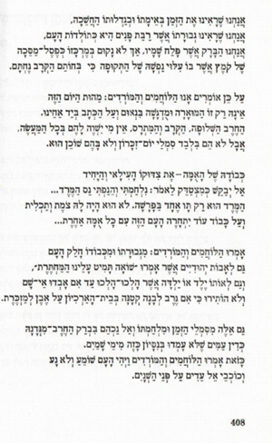

Facing the Glass Booth – Haim Guri
God’s Servants.
“ … and they had given me boiling water and a rag and told me to scrub the sidewalk by the Metropole hotel, the bucket was partly filled with acid, my hands bloated soon enough. They had brought out the chief rabbi; Dr Teglich, 70 years old. He too like me was ordered to wash the sidewalk. He did this while covered with his Talit, his prayer shawl. While he was lying on the ground, the guard had asked him; how do you like this? The rabbi responded, if God likes it, I am his servant.
I am writing these words down as Morris Fleishman, one of the former dignitaries of the Jewish Community of Vienna, is speaking.
I do not want to see him, I do not want to hear him, I would rather be at the NAHA”L parade today in the stadium, seeing strong beautiful people, but with an unimaginable strength, Morris Fleishman is holding me by my collar, as if he is saying: sit, hear, to the end.
“The shortest of the guards was five foot eight” – he says making me aware of how short he is…
These too are your own flesh and blood, I am telling myself. They at the position to demand that you sit to the through this. You are not running away from here. You are not escaping to the NAHA”L.

I return to the subject of: “Why didn’t you resist?”
“I think this is indescribable. A person who was not there, wouldn’t understand. It was the third year of the war. We had been through a lot. There was still some hope. We are working, they needed us. It was clear that if something small was to be done, there was no problem to do away with us. So many of them. It is impossible, after 18 years, to describe the fear. At the end of day it was a horrible fear. Facing the machine guns, watching a young boy being hung, losing your capacity to react. The belief that the war will end. There was a camp of a thousand Poles in the same situation. The camp was just a hundred meters away (330 feet) from their homes and they never tried to escape. Where could the Jews have gone? We were wearing concentration camp uniform, our head shaved. In 1943 we did not yet know what happened to the transports. We knew only later. It is impossible to describe today what had happened then”. Etc. etc…And so on and so forth.
The witness said all these things sitting down. At times his voice faded and became inaudible. Then abruptly he would speak up as if trying to justify himself to the judges, to his people, to the whole world.
5.2.1961
I escaped from the court house and to it.
So what do you say?
I am doomed if I talk and I am doomed if I do not.
……………………………………………………………
If we open a new page we should open it within us. We now see things differently.
We have created: “A Day of Commemoration for the Holocaust and Heroism” thus we have subtly separated between them. As if we had made them stand one facing the other as complementing one another but different from each other.
We were ashamed of the Holocaust as one is ashamed of a terrible blatant defect. And we have embraced heroism to our heart as a vestige of pride, the privilege to hold one’s head high.

God forbid that I should reach a point where the distinction is lost between the one who dies without battle and the one who rises or tries to resist the murderer. Fore a nation that chooses life, by its nature, will always prefer those who try to set a price for their doomed lives. Those who have given themselves and their people the desperate honor of the fighters for there lies the only chance for living.
But we need to ask forgiveness from countless people who we have judged in our heart. We who were outside of that circle. And we had judged them without asking ourselves, what gave us the right to do so?
A survey that Haaretz had run among Hebrew youth here who had never seen the Swastika whip, had shown that even at the beginning of this trial, there were people who had said: “Had we been there, we would not have gone like they did” or “we would have behaved differently.
Some of the respondents had said this with that Sabra pleasantness, and there was no silence or apology between the one who had asked the question and the one who responded.
…………………………………………………………………………………………

WHO – Michal Govrin
He who had kept his humanity even when turned into dust
A father who had sent his daughter to life,
A mother who had sent her son,
A granddaughter who had fought for her grandmother’s life,
A man who had held the hand of a Stanger

Who are the woman and man who held a gun
And inscribed the lines of freedom in Chronicles,
And he who kept up his forbidden commandment with tfilin
And she who distributed forged papers
And he who smuggled borders

He who wrote and painted and told stories and dreamt
And photographed and documented human testimonies,
He who laughed and loved,
She who wrote down recopies to make the hunger go away
Those who shared a slice of bread

He who held up the one who fell in the parade,
She who finished the slavery quota of her neighbour
Those who said a word of encouragement,
And those who, at twilight
In the shade of the crematorium
Stood up praying or singing.

Who are those children who played and dreamt and wrote their poems between fences,
And he who’s hand never left theirs
Even when they went to their death.

Who are those man, women, child and old woman;
Who sanctified the human image. צלם!

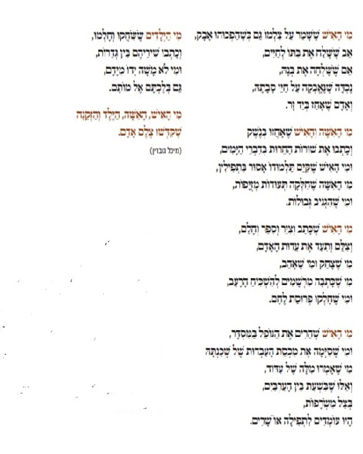
מי – מיכל גוברין
Messages from Sinai
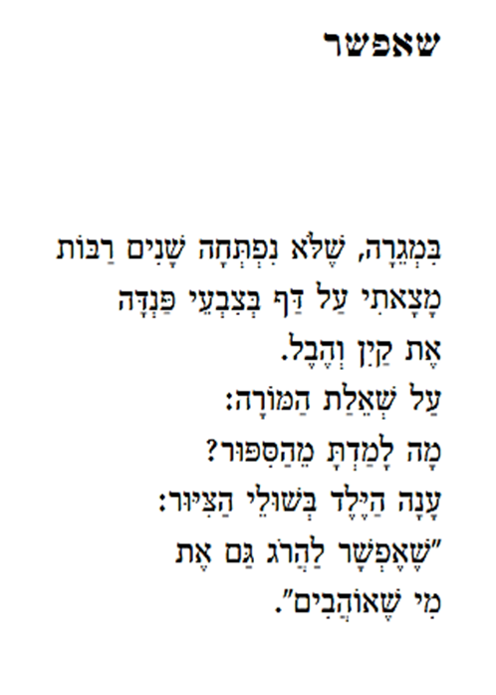
It is Possible - Giora Fischer
In the drawer that was not opened for many years
I found on a page, coloured with crayons
Cain and Able.
To the teacher’s question:
What did you learn from this story?
The kid at the picture’s margins, answered:
“It is possible to kill even
Those we love”

My Father Was God – Yehuda Amichai
My father was God and didn’t know it. He gave me
The Ten Commandments not in thunder and not in anger,
Not in fire and not in a cloud, but gently
And with love. He added caresses and tender words,
“Would you” and “please.” And chanted “remember” and “keep”
With the same tune, and pleaded and wept quietly
Between one commandment and the next: Thou shalt not
Take the name of thy Lord in vain, shalt not take, not in vain,
Please don’t bear false witness against your neighbor.
And he hugged me tight and whispered in my ear,
Thou shalt not steal, shalt not commit adultery, and shalt not kill.
And he lay the palms of his wide-open hands on my head
With the Yom Kippur blessing: Honor, love, that thy days
May be long upon this earth. And the voice of my father —
White as his hair. Then he turned his face to me one last time,
As on the day he died in my arms, and said, I would like to add
Two more commandments:
The Eleventh Commandment, “Thou shalt not change.”
And the Twelfth Commandment, “Thou shalt change. You will change.”
Thus spoke my father, and he turned and walked away
and disappeared into his strange distances.
אָבִי הָיָה אֱלהִים/ יהודה עמיחי
אָבִי הָיָה אֱלהִים וְלא יָדַע. הוּא נָתַן לִי
אֶת עֲשֶׁרֶת הַדִּבְּרוֹת לא בְּרַעַם וְלא בְּזַעַם, לא בָּאֵשׁ וְלא בָּעָנָן
אֶלָּא בְּרַכּוּת וּבְאַהֲבָה. וְהוֹסִיף לִטּוּפִים וְהוֹסִיף מִלִּים טוֹבוֹת,
וְהוֹסִיף "אָנָּא" וְהוֹסִיף "בְּבַקָּשָׁה". וְזִמֵּר זָכוֹר וְשָׁמוֹר
בְּנִגּוּן אֶחָד וְהִתְחַנֵּן וּבָכָה בְּשֶׁקֶט בֵּין דִּבֵּר לְדִּבֵּר,
לא תִּשָּׂא שֵׁם אֱלוֹהֶיךָ לַשָּׁוְא, לא תִּשָּׂא, לא לַשָּׁוְא,
אָנָּא, אַל תַּעֲנֶה בְּרֵעֲךָ עֵד שָׁקֶר. וְחִבֵּק אוֹתִי חָזָק וְלָחַשׁ בְּאָזְנִי,
לא תִּגְנוֹב, לא תִּנְאַף, לא תִּרְצַח. וְשָׂם אֶת כַּפּוֹת יָדָיו הַפְּתוּחוּת
עַל ראשִׁי בְּבִרְכַּת יוֹם כִּפּוּר. כַּבֵּד, אֱהַב, לְמַעַן יַאֲרִיכוּן יָמֶיךָ
עַל פְּנֵי הָאֲדָמָה. וְקוֹל אָבִי לָבָן כְּמוֹ שְׂעַר ראשׁוֹ.
אַחַר-כָּך הִפְנָה אֶת פָּנָיו אֵלַי בַּפַּעַם הָאַחֲרוֹנָה
כְּמוֹ בַּיוֹם שֶׁבּוֹ מֵת בִּזְרוֹעוֹתַי וְאָמַר: אֲנִי רוֹצֶה לְהוֹסִיף
שְׁנַיִם לַעֲשֶׂרֶת הַדִּבְּרוֹת:
הַדִּבֵּר הָאַחַד-עָשָׂר, "לא תִּשְׁתַּנֶּה"
וְהַדִּבֵּר הַשְּׁנֵים-עָשָׂר, "הִשְׁתַּנֵּה, תִּשְׁתַּנֶּה"
כָּךְ אָמַר אָבִי וּפָנָה מִמֶּנִי וְהָלַךְ
וְנֶעְלַם בְּמֶרְחַקָּיו הַמּוּזָרִים.

An infantry unit in the IDF

