Not Drying Swamp nor Dancing Hora

Only Yesterday S.Y. Agnon
Delicate Confession Nathan Zach
You Shall Walk in the Field Lea Goldberg

Not Drying Swamp nor Dancing Hora
Only Yesterday S. Y. Agnon

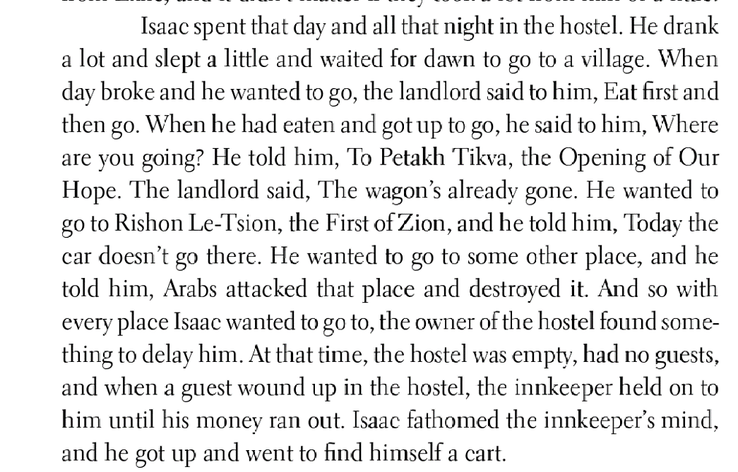

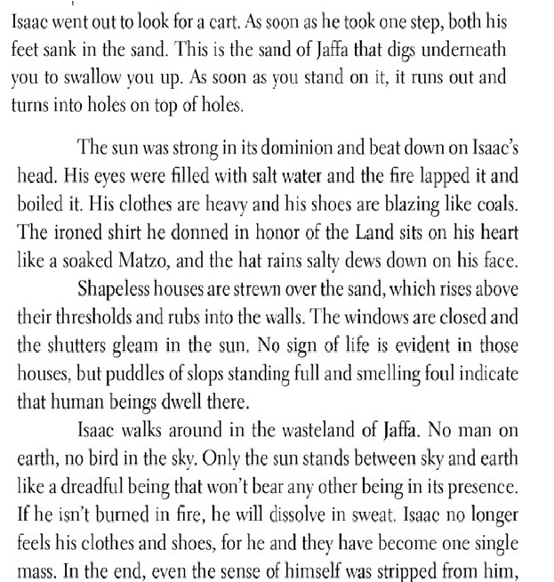

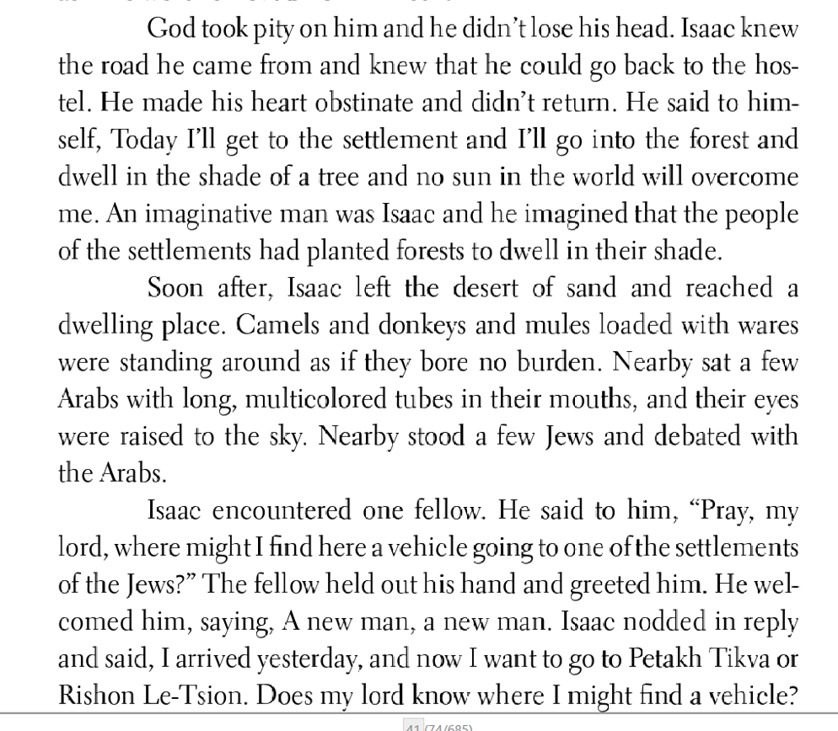

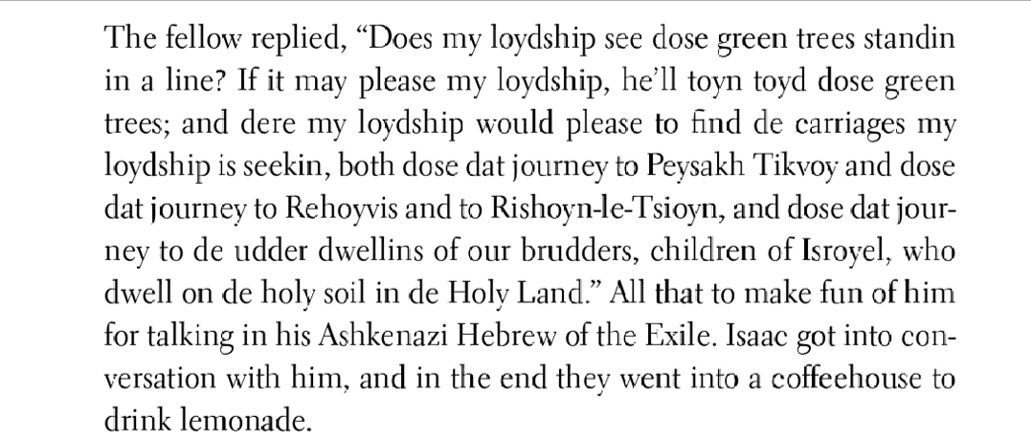

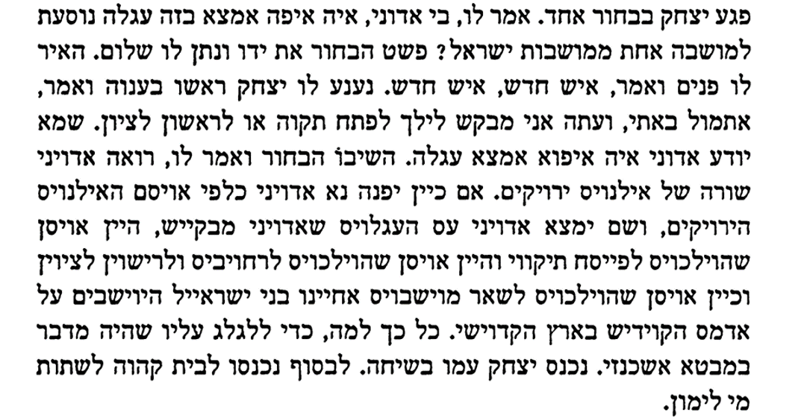
Delicate Confession Nathan Zach
I was born to be delicate.
Fact: I have soft hair.
You want to check? Be my guest,
My shampooed head is exposed to your gaze. Please excuse
The little bald patches. They’re just
The ravages of time.

I was born to be delicate. As it happens
My parents decided they should emigrate
To a country that is not delicate. They did not decide in haste,
They consulted with everyone. Even Hitler supported their decision,
He said it was very sensible.

That’s how someone born to be delicate
Came to a country that is not delicate. You tell me
What choice did I have? I still comb my hair
With a delicate comb, brush my teeth, lose my hair, send my clothes
To the cleaners. I never insult the neighbors except when
There's no choice.

It’s all a mistake, they said, a terrible mistake has been made. I myself
Make do with shouting in my sleep. Do you think
it will help?
Don’t make me laugh. I’m a serious person
If I had not been cursed by the generation, I mean my generation,
I would have a crushing answer for you
But maybe it wouldn’t be delicate.

וִידוּי עָדִין
נתן זך

נוֹלַדְתִי לִהְיוֹת עָדִין.
עוּבְדָה: יֵש לִי שְׂעָרוֹת עֲדִינוֹת.
אַתֶם רוֹצִים לִבְדוֹק? בְּבַקָשָה,
רֹאשִי הֶחָפוּף חָשׂוּף לִפְנֵיכֶם. אָנָא סִלְחוּ
עַל הַקָרָחוֹת הַקְטַנוֹת. זֶה רַק
שִינֵי הַזְמַן.

נוֹלַדְתִי לִהְיוֹת עָדִין. בְּמִקְרֶה
הֶחְלִיטוּ הוֹרַיי שֶהֵם צְרִיכִים לְהַגֵר
לְאֶרֶץ לֹא עֲדִינָה. הֵם לֹא הֶחְלִיטוּ בִּפְזִיזוּת,
הִתְיָיעֲצוּ עִם כָּל מִי שֶיָכְלוּ. אֲפִילוּ הִיטְלֶר תָמַךְ בַּהַחְלָטָה,
אָמַר שֶהִיא נְבוֹנָה בְּהֶחְלֵט.

כָּךְ הִגִיעַ מִי שֶנוֹלַד לִהְיוֹת עָדִין
לְאֶרֶץ לֹא עֲדִינָה. אִמְרוּ לִי אַתֶם:
אֵיזֶה בְּרֵרוֹת הָיוּ לִי. אֲנִי עֲדַיִין מִסְתָרֵק
בְּמַסְרֵק עָדִין, מְצַחְצֵחַ שִינַיִים, מַקְרִיחַ, מוֹסֵר בְּגָדִים
לְמִכְבָּסָה, לֹא מַעֲלִיב אֶת הַשְכֵנִים אֶלָא אִם כֵּן
אֵין בְּרֵרָה.

הַכּוֹל טָעוּת, אָמְרוּ, נָפְלָה כָּאן אֵיזוֹ טָעוּת נוֹרָאָה. אֲנִי עַצְמִי
מִסְתַפֵּק בְּכָךְ שֶאֲנִי צוֹעֵק בִּשְנָתִי. מָה דַעְתְכֶם,
זֶה יַעְזוֹר?!
אַל תַצְחִיקוּ אוֹתִי. אֲנִי בֶּן-אָדָם רְצִינִי
וְאִלְמָלֵא קִילֵל אוֹתִי הַדוֹר, וְהַכַּוָונָה לְדוֹרִי,
הָיִיתִי עוֹנֶה לָכֶם תְשוּבָה מוֹחֶצֶת
אֲבָל אוּלַי לֹא כָּל כָּךְ עֲדִינָה.

You Shall Walk in the Field Lea Goldberg
Is it true - will there ever come days of forgiveness and mercy?
And you'll walk in the field, and it will be an innocent's walk.
And your feet on the alfalfa's small leaves will be gently caressing,
And sweet will be stings, when you're stung by the rye's broken stalks!
And the drizzle will catch you in pounding raindrops' folly
On your shoulders, your breast and your neck, while your mind will be clean,
You will walk the wet field, and the silence will fill you -
As does light in a dark cloud's rim
And you'll breathe in the furrow in breaths calm and even,
And the pond's golden mirror will show you the Sun up above,
And once more all the things will be simple, and present, and living,
And once more you will love - yes, you will, yes, once more you will love!
You will walk. All alone. Never hurt by the blazing inferno
Of the fires on the roads fed by horrors too awful to stand,
And in your heart of hearts you'll be able to humbly surrender,
In the way of the weeds, in the way of free men.
Rachel Tzvia Back
And will they ever come, days of forgiveness and grace,
when you’ll walk in the fields, simple wanderer,
and your bare soles will be caressed by the clover,
or wheat-stubble will sting your feet, and its sting will be sweet?

Or the rainfall will catch you, the downpour pounding
on your shoulders, your breast, your neck, your head.
And you’ll walk in the wet fields, quiet widening within
like light on the cloud’s rim.

And you’ll breathe in the scent of the furrow, full and calm,
and you’ll see the sun in the rain-pool’s golden mirror,
and all things are simple and alive, and you may touch them,
you are allowed, you are allowed to love.

You’ll walk in the field. Alone, not scorched by the blaze
of the fires, along roads stiffened with blood and terror.
And true to your heart you’ll be humble and softened,
as one of the grass, as one of humankind.[2]
