To Each Their Own Shabbat

Clean Folk Song Ehud Manor

A Poem for Friday Night Yehuda Amichai

Shabbat Morning Tirza Attar

Maybe on Shabbat Uri Orbach

Kabbalat Shabbat (Welcoming Shabbat) Agi Mishol

Delicate Balance Sivan Har Shefi

Shabbat the Queen H. N. Bialik

שיר עם נקי

מילים: אהוד מנור
לחן: מתי כספי

ערב יום שבת,
שעה חמש עד שש,
וכל אחד כמעט
שוב מתחדש.
בכל שבעה ימים
המקלחות שרות,
המים שוב חמים בצינורות.

פזמון:
שביל באמצע, שביל בצד,
חפופים אחד אחד.
איזה נקיון וסדר
איזה יופי של מצעד.

מים וסבון,
חשמל דופק שעון
ולא עושים חשבון
עם החשבון.
מי בושם לפנים,
חולצת שבת יפה,
וזוג של לבנים
להחלפה.

פזמון:
שביל באמצע, שביל בצד...

רגע של חלום
לגוף ולנשמה,
כולם אומרים "שלום"
ו"מה נשמע?"
אפילו גוף חורק
מרגיש פתאום טרי,
וכל אחד שורק
שיר עם נקי.

Clean Folk Song

Words: Ehud Manor
Melody: Mati Caspi

Friday afternoon,
Between five and six,
Everyone is getting ready
Again – as good as new.
Every seven days
The showers sing,
The water is hot again.

Refrain:
Center part, side part,
Everyone’s hair is washed.
How clean and neat we are
How nice we look!

Soap and water
The electric meter is running
But we don’t care
About the cost.
A splash of aftershave,
A nice shirt,
And a spare set
Of underwear.

Refrain:
Center part, side part…

Time for the body and the soul
To dream,
Everyone says “Shalom”
And “What’s doing?”
Even creaky bones
Suddenly feel rejuvenated,
And everyone whistles
A Clean Folk Song

A Poem for Friday Night
Yehuda Amichai

Will you come to me tonight?
The washing has already dried in the yard.
The never-ending war,
Is somewhere else right now.

Roads return unceasingly
By themselves, like a riderless horse
And the house is closes up at night
Upon the good and the bad within.

We well knew that the border is
Close by, and forbidden there.
Father prayed: “And they were completed –
The earth and all its hosts.”

Hosts and earth darkrned,
Soon the lights will fade.
The commandment begun by the heavens
Must again be consummated by two.
שיר ליל שבת
מילים: יהודה עמיחי

התבואי אלי הלילה
כבסים כבר יבשו בחצר.
מלחמה שאף פעם לא די לה,
היא עכשיו במקום אחר

וכבישים שבים בלי הרף
לבדם כסוס בלי רוכבו
והבית נסגר בערב
על הטוב והרע שבו,

וידענו היטב, כי הגבול הוא
קרוב, ואסור לנו שם.
אבי התפלל: ויכולו
הארץ וכל צבאם.

צבא והארץ האפילו,
עוד מעט וכבה האור.
המצווה בה שמים התחילו
שוב השנים צריכים לגמור.

Tirza Attar (1941-1977) A poet, lyrics writer and story teller. Many of her poems and songs were set to music and are still sung frequently.
Shabbat Morning – is a wimsical description of Shabbat for the non observant secular Israelis. Yet note the many references to "permited”and „forbidden”things to do?

Shabbat Morning Tirzah Attar
Saturday morning! What a lovely day
Mom drinks lots of coffee
Dad reads lots of newspaper
And they’re going to buy me lots of balloons.

We may go to the Yarkon,
To sail a boat
Or walk to the end of the road
And back again.
We can pick flowers,
The ones we’re permitted to pick
And we can go to pre-school
And see that it’s closed.

שבת בבוקר תרצה אתר
שבת בבוקר! יום יפה
אמא שותה המון קפה
אבא קורא המון עיתון
ולי יקנו המון בלון.

אפשר ללכת לירקון,
לשוט שם בסירה
או לטייל עד סוף הרחוב
ולשוב בחזרה
אפשר לקטוף פרחים,
כאלה שלא אסור
ואפשר ללכת עד הגן
ולראות שהוא סגור.

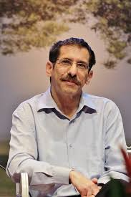
Uri Orbach (1960-2015) Journalist, writer and funny story teller. Member of the Knesset and Minister for Senior Citizens affairs in the Israeli governement.
His poem “Maybe on Shabbat” is one of many depicting life of modern Orthodox kids in Israel. Following his untimely death, his passing is commemorated by distributing sweets during Shabbat services on the date of his passing.
Maybe on Shabbat Uri Orbach

אולי בשבת – אורי אורבך
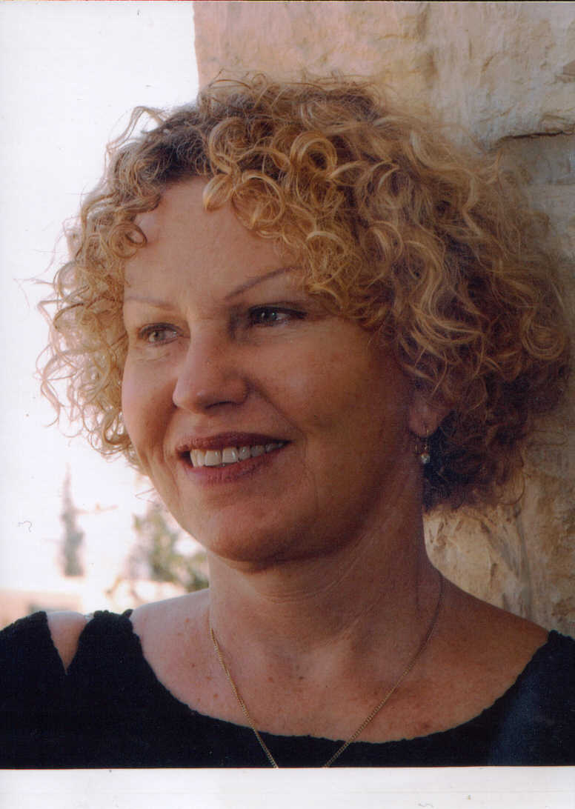
Agi Mishol (1946) Worldwide acclaimed Israeli poet and teacher of literature.
Note the tone of defiance again practically all cherished Shabbat symbols? Where is anger coming from, do you think?

Kabalat Shabbat (Welcoming Shabbat) Agi Mishol
Fuck the stain of grace
That spread out from my chest
Into the world

Shabbat the queen can suck it up
With all its cousins
With the chicken in the oven
My father and my mother
And my husband and my kids as well as the sun
That finally left
The top of the trees.

קבלת שבת , אגי משעול
קוּס אוֹחְתוֹ כֶּתֶם הַחֶסֶד
שֶׁהִתְפַּשֵּׁט מֵחָזִי
לְתוֹךְ הָעוֹלָם
וְשֶׁתִּקְפֹּץ לִי שַׁבָּת הַמַּלְכָּה
עִם כָּל בְּנֵי דוֹדֶיהָ
וְעִם הָעוֹף בַּתַּנּוּר
וְאָבִי וְאִמִּי
וּבְעָלַי וִילָדַי וְהַחַמָּה
שְׁנִּסְתַּלְּקָה סוֹף סוֹף
מֵרָאשֵׁי הָאִילָנוֹת
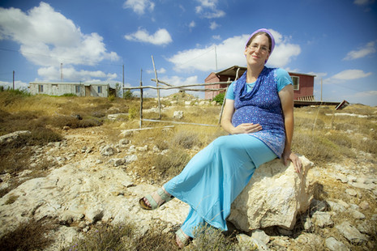
Sivan Har Shefi (1978) A highly acclaimed poet, whose poetry articulates the tension and the complementary aspects of the holy and the mundane. She is one of the most important feminist poetic voices of Modern Orthodoxy in Israel today.

Delicate Balance Sivan Har-Shefi
Our Shabbat
The one only I can bring in
And only you can let go (leave, out)
Holding two candles
But when it ends they become one
Two wicks in one candle
For a new beginning
In the beginning we were two faced
The world was hanging by a spinal cord
Now two spinal columns
Are holding a home
And when I bend a little,
When you. Delicate balance.

איזון עדין, סיון הר-שפי
אֶת הַשַּׁבָּת שֶׁלָּנוּ
שֶׁרַק אֲנִי יְכוֹלָה לְהַכְנִיס
שֶׁרַק אַתָּה יָכוֹל לְהוֹצִיא
מַחְזִיקִים שְׁנֵי נֵרוֹת.
אֲבָל בְּסוֹפָהּ נִהְיִים אֶחָד
שְׁתֵּי פְּתִילוֹת בְּנֵר אֶחָד
לְהַתְחָלָה חֲדָשָׁה.
וּבְרֵאשִׁית הָיִינוּ דּוּ-פַּרְצוּפִין
בְּחוּט שִׁדְרָה הָיָה תָּלוּי עוֹלָם.
עַכְשָׁו שְׁנֵי עַמּוּדֵי שִׁדְרָה
מַחְזִיקִים בַּיִת
וּכְשֶׁאֲנִי קְצָת מִתְכּוֹפֶפֶת,
וּכְשֶׁאַתָּה. אִזּוּן עָדִין.

